Assignment No. : 1
TITLE
Case Study: Visit different websites (Min. 5) for the different client projects and note down the evaluation results for these websites, either good website or bad website. OBJECTIVES
PROBLEM STATEMENT
Visit 5 different websites (Government, Industry, University, Mart, Industry, Organization, Healthcare, Medical, Social, Personal,etc.) for the different client projects and note down the evaluation results for these websites, either good website or bad website in following format:

Sr. No. | Website URL | Purpose of Website | Things liked in the website | Things disliked in the website | Overall evaluation of the website (Good/Bad)

OUTCOME
Students will be able to understand the importance of website planning and website design issues.

SOFTWARE & HARDWARE REQUIREMENTS
Text Editor, Internet Browser.

THEORY-CONCEPT
Web Application:
A web application runs over the Internet. Ex. eBay,Amazon ,Google, facebooketc
A webapp contains five components:
1.HTTP Server: Examples are- Google Web Server , Apache HTTP Server, Apache Tomcat Server, Microsoft Internet Information Server (IIS) etc
2.HTTP Client (Web Browser): Examples are- Internet Explorer, Firefox, Google Chrome, Safari etc.
3.Database:Examples are- MySQL, Apache Derby, MS SQL Server, SQLite, PostgreSQL, Commercial Oracle, IBM DB2, SAP SyBase, MS Access etc
4.Client-Side Programs: It can be written in HTML Form,VBScript, JavaScript, Flash etc.
5.Server-Side Programs: could be written in Java Servlet/JSP, ASP, PHP, Perl, Python, CGI, and others.
A web app is 3-tier (or multi-tier) client-server database application which run over the Internet as shown in the following diagram,

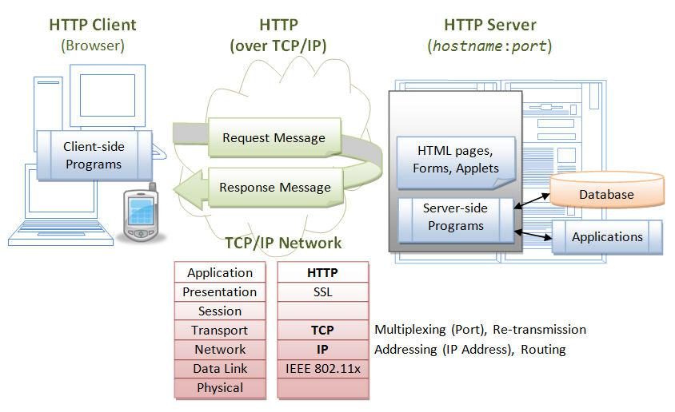

Figure.1: Three-Tier Client-Server Architecture
- To start a webapp, A user, issues a URL request via a web browser (HTTP client), to HTTP server.
- The HTTP server returns an HTML form (client-side program), which is loaded into the client's browser.
- The user fills up the query data inside the form and submits that form.
- The client-side program sends the query parameters to a server-side program.
- The server-side program receives the query parameters, queries the database based on these parameters, and returns the query result to the client-side program.
- The client-side program displays the query result on the browser.
- The process repeats for the next request.

CONCLUSION / ANALYSIS
Hence, we have performed the case study for 5 different websites and evaluated website design as good or bad considering different website design issues which must be considered during website design.

ORAL QUESTIONS
- Describe phases of website development in brief and discuss design issues.
- Difference between static and dynamic web pages.
- Define the terms i. Website, ii. Web Page, iii. Web Server, iv. URL and v. Home Page.
- What are the different design issues in web development?
- Describe the steps involved when a web browser requests for and obtains a web page from a web server.
- What are major differences between the two web browser- Internet Explorer and Mozilla
Firefox.
- How you can set up your own website. What are the requirements for the same?
- Enlist applications of static & dynamic web page.
- Why is HTTP called a stateless protocol? Why is it so?

Assignment No. : 2
TITLE
Design and develop any suitable web application using HTMLand CSS.

OBJECTIVES
- Understand about basic concepts of html
- Understand the basic concepts of CSS

PROBLEM STATEMENT
Implement a web page index.htm for any client website (e.g., a restaurant website
project) using following:
a. HTML syntax: heading tags, basic tags and attributes, frames, tables, images, lists,
links for text and images, forms etc.
b. Use of Internal CSS, Inline CSS, External CSS
OUTCOME
Students will be able to,
- Design static webpage using HTML.
- Apply CSS to HTML pages.

SOFTWARE & HARDWARE REQUIREMENTS
Software: Notepad/Text Editor, Browser

THEORY-CONCEPT
HTML: HTML is the standard markup language for creating Web pages.
- HTML stands for Hyper Text Markup Language
- HTML describes the structure of Web pages using markup
- HTML elements are the building blocks of HTML pages
- HTML elements are represented by tags
- HTML tags label pieces of content such as "heading", "paragraph", "table", and so on
- Browsers do not display the HTML tags, but use them to render the content of the page
- HTML Versions:

HTML | 1991
HTML 2.0 | 1995
HTML 3.2 | 1997
HTML 4.01 | 1999
XHTML | 2000
HTML 5 | 2014
Table.1: HTML Versions

CSS:
CSS stands for Cascading Style Sheet. It is nothing, but design language intended to simplify the process of making web pages presentable.CSS handles the feel and look part of a web page.By using CSS, one can control the color of text, style of fonts, spacing between paragraphs, layout designs.
CSS is easy to learn, easy to understandand it provides powerful control on presentation of an HTML document.
Advantages of CSS:
It saves the time, Pages load faster, Easy maintenance, Superior styles to HTML, Multiple Device Compatibility, Global web standards, Offline Browsing, Platform Independence.
CSS3 Modules:
CSS3 Modules are having old CSS specifications as well as extension features.
- Box Model
- Selectors
- Background
- Border
- Image Values and Replaced Content
- Text Effects
- Animations
- 2D/3D Transformations
- Multiple Column Layout
- User Interface

TECHNOLOGY / TOOL
- The <!DOCTYPE html> declaration defines this document to be HTML5
- The <html> element is the root element of an HTML page
- The <head> element contains meta information about the document
- The <title> element specifies a title for the document
- The <body> element contains the visible page content
- The <h1> element defines a large heading
- The <p> element defines a paragraph
- HTML tags are element names surrounded by angle brackets: <tagname>content goes here...</tagname>
CSS can be added to HTML elements in 3 ways:
- Inline - by using the style attribute in HTML elements. An inline CSS is used to apply a unique style to a single HTML element.
  - Ex. <h1 style="color:blue;">This is a Blue Heading</h1>
- Internal - by using a <style> element in the <head> section. An internal CSS is used to define a style for a single HTML page. An internal CSS is defined in the <head> section of an HTML page, within a <style> element.
Example:<style>
body {background-color: powderblue;}
h1 {color: blue;}
p {color: red;} </style>
- External - by using an external CSS file. An external style sheet is used to define the style for many HTML pages. With an external style sheet, you can change the look of an entire web site, by changing one file!To use an external style sheet, add a link to it in the <head> section of the HTML page.
Example: <link rel="stylesheet" href="styles.css">
- Use the HTML <head> element to store <style> and <link> elements
- Use the CSS color property for text colors
- Use the CSS font-family property for text fonts
- Use the CSS font-size property for text sizes
- Use the CSS border property for borders
- Use the CSS padding property for space inside the border
- Use the CSS margin property for space outside the border

DESIGN / EXECUTION STEPS
Following steps are used to Create and Execute web applications,
- Write the HTML code in notepad and save with .html extension.
- Write the CSS code in notepad and save with .css extension.
- Import CSS file in HTML page.
- Open HTML page in the browser.

TEST CASES
Manual testing is used to check whether CSS gets applied or not.

CONCLUSION/ANALYSIS
Hence, we have designed static web pages using HTML and CSS.

PROGRAM CODE & OUTPUT

Registration.html

<html>
<head>
<title>regform</title>
<link href="samp.css" rel="stylesheet"></link> </head>
<body>
<div class="con">
<form action="display.html" method="get" align="center"> <div class="con2">
<imgsrc="D:/handshake.jpg" width=380px height=100px></img>
</div>
<div class="main">
<table align="center">
<tr>
<td><b><br>Welcome to Registration Page<br><br></td></tr>
</table>
<div class="con1">
<table align="center">
<tr><td>Full Name:</td>
<td><input type="text" value=""></input></td>
</tr><tr><td>Class</td>
<td><input type="text" value=""></input></td>
</tr>
<tr>
<td>Department</td>
<td><input type="text" value=""></input></td>
</tr>
<tr>
<td>address:</td>
<td><textarea row="3" column="2"></textarea></td>
</tr><tr>
<td>email:</td>
<td><input type="text" value=""></input></td>
</tr><tr><td>phone:</td>
<td><input type="text" value=""></input></td>
</tr>
<tr></tr><tr></tr>
</table>
<table align="center">
<tr>
<td><input type="submit" value="SUBMIT"></td> <td><input type="reset" value="CANCEL"></td>
</tr>
</table>
</div>
</div>
</form>
</div>
</body>
</html>

samp.css
.con
{
width:400px;
height:400px;
background-color:blue;
color:blue;
padding:0px 10px 0px 10px;
margin:auto;
}
.main
{
width:400px;
height:80px;
float:left;
padding:60px 10px 10px10px;
margin: auto;
}
.con1
{

width:200px;
height:30px;
float:left;
margin:auto;
padding:0px 0px 0px0px;
}
.con2
{
width:150px;
height:30px;
float:left;
margin:10px 10px 10px10px;
padding:0px 0px 0px0px;
}
Display.css
<html>
<head>
<title> display</title>
</head>
<body>
<h1 style="color:blue;margin-left:30px;"> You have submitted the form successfully….</h1>
</body>
</html>
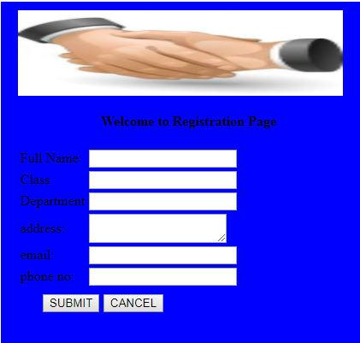
Sample Output:

ORAL QUESTIONS
- What is the difference between HTML and HTML5?
- What is the difference between html elements and tags?
- What is marquee?
- What is the use of span tag? Give an example?
- What is the use of ‘required ’attribute in HTML5?
- What is External stylesheet? What are the advantages and disadvantages?
- What is CSS selector?
- What are the components of CSS style?
- What are browser safe color?

Assignment No. : 3

TITLE
XML and CSS

PROBLEM STATEMENT
Design the XML document to store the information of the employees of any business
organization and demonstrate the use of:
a) DTD
b) XML Schema
And display the content in (e.g., tabular format) by using CSS/XSL.
OUTCOMES
Students will be able to,
- Design static webpage using XML.
- Apply CSS to XML pages.

SOFTWARE & HARDWARE REQUIREMENTS
Software: Notepad, Any Browser

THEORY-CONCEPT
XML stands for Extensible Markup Language. It is nothing but the text-based markup language which is derived from Standard Generalized Markup Language (SGML).
XML tags identify the data and are used to store and organize the data, rather than specifying how to display it like HTML tags, which are used to display the data. XML is not going to replace HTML in the near future, but it introduces new possibilities by adopting many successful features of HTML.
There are three important characteristics of XML that make it useful in a variety of systems and solutions −
- XML is extensible − XML allows you to create your own self-descriptive tags, or language, that suits your application.
- XML carries the data, does not present it − XML allows you to store the data irrespective of how it will be presented.
XML is a public standard − XML was developed by an organization called the World Wide Web Consortium (W3C) and is available as an open standard.

TECHNOLOGY/TOOL
The XML document have an XML declaration, but it is optional, and it is written as−
<? xml version = "1.0" encoding = "UTF-8"?>
Where version is nothing but the version of an XML document and UTF specifies the character-encoding used in the document.
Each XML-element needs to be closed either with start or with end elements as shown below −
<element>………</element>
An XML document can have only one root element. <root>
<x>...</x>
<y>...</y>
</root>

XML Attributes:
Using a name/value pair, an attribute specifies a single property for an element. An XML-element can have one or more attributes. For example −
<a href = "http://www.google.com/">XMLTutorial</a>
Here href is the attribute name and http://www.google.com/ is attribute value.

DESIGN/EXECUTION STEPS
Following steps are used to Create and Execute web applications,
- Write the XML code in notepad and save with .xml extension.
- Write the CSS code in notepad and save with .css extension.
- Import CSS file in XML page.
- Open XML page in the browser.

TEST CASES
Manual testing is used to check whether CSS gets applied or not.

CONCLUSION/ANALYSIS
Hence, we have designed static web page using XML and CSS

PROGRAM CODE & OUTPUT
Employee.xml
<?xml version="1.0"?>
<?xml-stylesheet type="text/css" href="cssemployee.css"?>
<!DOCTYPE employee SYSTEM "employee.dtd">
<employee>
<id> 01 </id>
<firstname>Ram</firstname>
<lastname>Prasad</lastname>
<email>ram@gmail.com </email>

<id> 02 </id>
<firstname>Smita</firstname>
<lastname>Khairnar</lastname>
<email>smita@gmail.com </email>
</employee>

cssemployee.css
employee
{
background-color: pink;
}

id,firstname,lastname,email
{
font-size:25px;
display:block;
color: blue;
margin-left: 50px;
}

Book.xml

<?xml version="1.0" encoding="UTF-8"?>
<?xml-stylesheet type="text/css" href="book_catalog.css"?>
<CATALOG>
<BOOK>
<TITLE>Database Management System</TITLE>
<AUTHOR>Korth</AUTHOR>
<PRICE>500</PRICE>
<YEAR>1985</YEAR>
</BOOK>
<BOOK>
<TITLE>Computer Network</TITLE>
<AUTHOR>Tenenbaum</AUTHOR>
<PRICE>600</PRICE>
<YEAR>1985</YEAR>
</BOOK>
<BOOK>
<TITLE>Software Engineering and project Management</TITLE>
<AUTHOR>Roger Pressman</AUTHOR>
<PRICE>600</PRICE>
<YEAR>1985</YEAR>
</BOOK>
</CATALOG>

book_catalog.css
BOOK {
Display: block;
margin-left:0;
magin-bottom: 30pt;
}
CATALOG {
Width:100%;
background-color: #ffffff;
}
TITLE {
Color: ff0000;
display: block;
font-size: 20pt;
}
AUTHOR {

display: block;
color: #0000ff;
font-size: 20pt;
}
YEAR, PRICE {
Color:#00000;
Display: block;
Margin-left: 20pt;
}

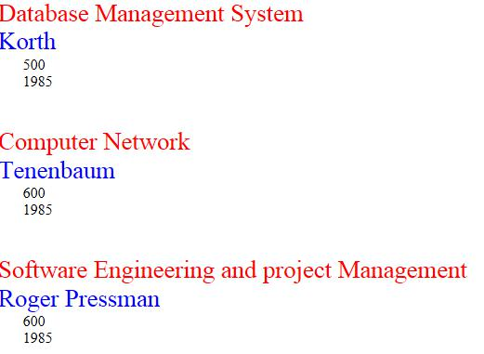
Output:

Example 2
Employee.xml
<?xml version="1.0"?>
<?xml-stylesheet type="text/css" href="emp.css"?>
<!DOCTYPE globe>
<globe>
<Country>
<name>United States of America</name>
<areawidth>50,000</areawidth>
<capital>Washington,D.C</capital>
</Country>
<Country>
<name>Canada</name>
<areawidth>1,00000</areawidth>
<capital>Ottawa</capital>
</Country>
<Country>
<name>Norway</name>
<areawidth>60,000</areawidth>
<capital>Oslo</capital>
</Country>
<Country>
<name>Singapore</name>
<areawidth>65,000</areawidth>
<capital>Singapore</capital>
</Country>
<Country>
<name>England</name>
<areawidth>15,000</areawidth>
<capital>London</capital>
</Country>
</globe>

Emp.css
globe:before {
display: semi-block;
width: 9em;
font-weight: bold;
font-size: 170%;
content: "Country";
margin: -.85em 0px .35em -.35em;
padding: .2em .20em;
background-color: #FF0000;
}
globe {
display: block;
margin: 2em 1em;
border: 4px solid #B22222;
padding: 0px 1em;
background-color: #cdf;
}
Country {
display: block;
margin-bottom: 1.5em;
}
name {
display: block;
font-weight: bold;
font-size: 140%;
}
areawidth {
display: block;
}
areawidth:before {
content: "Area width: ";
}
area:after {
content: " million km\B2";
}
depth {
display: block;
}
depth:before {
content: "Mean depth: ";
}
depth:after {
content: " m";

ORAL QUESTIONS

- Explain difference between HTML and XML?
- What is XML DOM?
- Explain difference between CDATA and PCDATA?
- What is mean by simple element and complex element?
- What is XPATH?
- Explain XSL and XSLT?

Assignment No. - 4

TITLE
HTML, Java Script

OBJECTIVES
- Understand about basic concepts of JavaScript.
- Use JavaScript for validation of data.

PROBLEM STATEMENT
Implement an application in Java Script using following:
a) Design UI of application using HTML, CSS etc.
b) Include Java script validation
c) Use of prompt and alert window using Java Script
e.g., Design and implement a simple calculator using Java Script for operations like addition, multiplication, subtraction, division, square of number etc.
a) Design calculator interface like text field for input and output, buttons for numbers and operators etc.
b) Validate input values
c) Prompt/alerts for invalid values etc.

OUTCOMES
Students will be able to,
- Design static webpage using HTML.
- Apply JavaScript to HTML pages for validation of data.

SOFTWARE & HARDWARE REQUIREMENTS
Software’s: Notepad, Any Browser

THEORY-CONCEPT
JavaScript is a programming language of HTML as well web. It is preferred for creating network-centric applications. It is integrated and complimentary with Java. As JavaScript is integrated with HTML it is very easy to implement. It is open as well as cross-platform.
Advantages:
The advantages of using JavaScript are −
- It requires less server interaction
- Immediate feedback to the visitors
- Increased interactivity
- Richer interfaces
Validation:
When client enters the all necessary data and press the submit button form validation is done at server side If data entered by a client is incorrect or missing,the server needs to send all data back to the client and request for resubmission of form with correct information. This is really a lengthy process which puts a lot of load(burden) on the server.
So, JavaScript provides a way to validate form's data on the client's side itself before sending it to the web server. Form validation performs two functions-
- Basic Validation –First of all the form must be checked to make sure all the mandatory fields are filled in. It would require just a loop through each field in the form and check for the data.
- Data Format Validation − Secondly, the data that is entered must be checked for correct format and its value. The code must include appropriate logic to test correctness of data.

TECHNOLOGY/TOOL
JavaScript can be implemented using JavaScript statements that are placed within the <script>.
You can place the <script> tags, containing your JavaScript, anywhere within your web page, but it is normally recommended that you should keep it within the <head> tags.
The script tag takes two important attributes:
- Language − This attribute specifies what scripting language you are using. Typically, its value will be JavaScript. Although recent versions of HTML (and XHTML, its successor) have phased out the use of this attribute.
- Type − This attribute is what is now recommended to indicate the scripting language in use and its value should be set to "text/JavaScript".

DESIGN/EXECUTION STEPS
Following steps are used to Create and Execute web applications,
- Write an HTML code in notepad and save with .html extension.
- Write the function for validation of email id and phone no and enclosed this function in script.
- Call this function on ‘onClick’ event of submit button.
- Open HTML page in the browser.

TEST CASES
Manual testing is used to check following validations
- All the fields like Full name, Class, Department, Address, Phone number and email id are mandatory fields.

- Phone no. should be numbers only.
- Email id should be in proper format like abc@abc.com

CONCLUSION/ANALYSIS
Hence, we applied validate the data using JavaScript.

PROGRAM CODE & OUTPUT
Registration.html
<html>
<head>
<title>regform</title>
<link href="samp.css" rel="stylesheet"></link>
<script type="text/javascript">
function Validation()
{
varemailID = document.myForm.EMail.value;
varnum=document.myForm.ph.value;
atpos = emailID.indexOf("@");
dotpos = emailID.lastIndexOf(".");
if (atpos< 1 || ( dotpos - atpos< 2 ))
{
alert("Please enter correct email ID")
document.myForm.EMail.focus() ;
return false;
}
else if (isNaN(num)){
document.getElementById("ph");
alert("Please enter numeric only.")
return false;
}else{
return true;
}
}
</script>
</head>
<body>
<div class="con">
<form name="myForm" action="display.xml" method="get" align="center"> <div class="con2">
<imgsrc="D:/handshake.jpg" width=380px
height=100px></img>
</div>
<div class="main">
<table align="center">

<tr><td><b><br>Welcome to Registration Page<br><br></td></tr> </table>
<div class="con1">
<table align="center">
<tr>
<td>Full Name:</td>
<td><input type="text" id="FirstName" value="" required></input></td> </tr>
<tr>
<td>Class:</td>
<td><input type="text" id="Class" value="" required></input></td>
</tr>
<tr>
<td>Department:</td>
<td><input type="text" id="Department" value="" required></input></td>
</tr>
<tr>
<td>address:</td> <td><textarea row="3" column="2" value="" required></textarea></td>
</tr>
<tr>
<td>email Id:</td>
<td><input type="text" value="" id="EMail" required></input></td>
</tr>
<tr>
<td>phone no:</td>
<td><input type="text" id="ph" value="" required></input></td>
</tr>
<tr>
<tr></tr><tr></tr></table>
<table align="center">
<td><input type="submit" value="SUBMIT" onclick="return(Validation());"></td>
<td><input type="reset" value="CANCEL"></td> </tr>
</table>
</div>
</div>
</form>
</div>
</body>
</html>

Output:
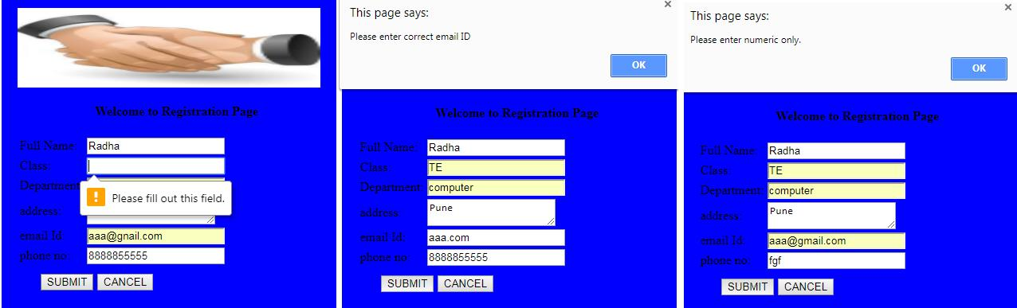

Example 2
Field Level registration Form.html
<!DOCTYPE html><html lang="en"><head>
<meta charset="utf-8">
<title>JavaScript Field Label Form Validation using a registration form</title>
<meta name="keywords" content="example, JavaScript Form Validation, Sample registration form" />
<meta name="description" content="This document is an example of JavaScript Field label form validation using a sample registration form. " />
<link rel='stylesheet' href='js-field-level-form-validation.css' type='text/css' />
<script src="field-level-sample-registration-form-validation.js"></script>
</head>
<body onload="firstfocus();">
<h1>JavaScript Field Label Form Validation using a registration form</h1>
<h2>Use tab key or mouse to go next field</h2><form name='registration'">
<ul>
<li><label for="userid">User id [5 to 12 characters] :</label></li>
<li><input type="text" name="userid" size="12" onblur="userid_validation(5,12)"/></li>
<li><label for="passid">Password [7 to 12 characters] :</label></li>
<li><input type="password" name="passid" size="12" onblur="passid_validation(7,12)"/></li>
<li><label for="username">Name [Alphabates characters] :</label></li>
<li><input type="text" name="username" size="50" onblur="allLetter()"/></li>
<li><label for="address">Address [alphanumeric characters] :</label></li>
<li><input type="text" name="address" size="50" onblur="alphanumeric()"/></li>
<li><label for="country">Country [Must select a country] :</label></li>
<li><select name="country" onblur="countryselect()">
<option selected="" value="Default">(Please select a country)</option>
<option value="AF">Australia</option>
<option value="AL">Canada</option>
<option value="DZ">India</option>
<option value="AS">Russia</option>
<option value="AD">USA</option>
</select></li>
<li><label for="zip">ZIP Code [numeric characters] :</label></li>
<li><input type="text" name="zip" onblur="allnumeric()"/></li>
<li><label for="email">Email [Valid email] :</label></li>
<li><input type="text" name="email" size="50" onblur="ValidateEmail()" /></li>
<li><label id="gender">Sex [Select Male or Female] :</label></li>
<li><input type="radio" name="sex" value="Male" checked /><span>Male</span></li>
<li><input type="radio" name="sex" value="Female" /><span>Female</span></li>
<li><label>Language [Optional] :</label></li>
<li><input type="checkbox" name="en" value="en" checked /><span>English</span></li>
<li><input type="checkbox" name="nonen" value="noen" /><span>Non English</span></li>
<li><label for="desc">About [Optional] :</label></li>
<li><textarea name="desc" id="desc"></textarea></li>
<li><input type="submit" name="submit" value="Submit" onclick="alert('Form submitted successfully')" /></li>
</ul>
</form>
</body>
</html>

field-level-sample-registration-form-validation.js
// After form loads focus will go to User id field.
function firstfocus()
{
var uid = document.registration.userid.focus();
return true;
}
// This function will validate User id.
function userid_validation(mx,my)
{
var uid = document.registration.userid;
var uid_len = uid.value.length;
if (uid_len == 0 || uid_len >= my || uid_len < mx)
{
alert("User Id should not be empty / length be between "+mx+" to "+my);
uid.focus();
return false;
}
// Focus goes to next field i.e. Password.
document.registration.passid.focus();
return true;
}
// This function will validate Password.
function passid_validation(mx,my)
{
var passid = document.registration.passid;
var passid_len = passid.value.length;
if (passid_len == 0 ||passid_len >= my || passid_len < mx)
{
alert("Password should not be empty / length be between "+mx+" to "+my);
passid.focus();
return false;
}
// Focus goes to next field i.e. Name.
document.registration.username.focus();
return true;
}
// This function will validate Name.
function allLetter()
{
var uname = document.registration.username;
var letters = /^[A-Za-z]+$/;
if(uname.value.match(letters))
{
// Focus goes to next field i.e. Address.
document.registration.address.focus();
return true;
}
else
{
alert('Username must have alphabet characters only');
uname.focus();

return false;
}
}
// This function will validate Address.
function alphanumeric()
{
var uadd = document.registration.address;
var letters = /^[0-9a-zA-Z]+$/;
if(uadd.value.match(letters))
{
// Focus goes to next field i.e. Country.
document.registration.country.focus();
return true;
}
else
{
alert('User address must have alphanumeric characters only');
uadd.focus();
return false;
}
}
// This function will select country name.
function countryselect()
{
var ucountry = document.registration.country;
if(ucountry.value == "Default")
{
alert('Select your country from the list');
ucountry.focus();
return false;
}
else
{
// Focus goes to next field i.e. ZIP Code.
document.registration.zip.focus();
return true;
}
}
// This function will validate ZIP Code.
function allnumeric()
{
var uzip = document.registration.zip;
var numbers = /^[0-9]+$/;
if(uzip.value.match(numbers))
{
// Focus goes to next field i.e. email.
document.registration.email.focus();
return true;
}
else
{
alert('ZIP code must have numeric characters only');
uzip.focus();
return false;
}
}
// This function will validate Email.
function ValidateEmail()
{
var uemail = document.registration.email;
var mailformat = /^\w+([\.-]?\w+)*@\w+([\.-]?\w+)*(\.\w{2,3})+$/;
if(uemail.value.match(mailformat))
{
document.registration.desc.focus();
return true;
}
else
{
alert("You have entered an invalid email address!");
uemail.focus();
return false;
}
}

js-field-level-form-validation.css
h1{
margin-left: 50px;
color: navy;
}
h2{
margin-left: 50px;
color: navy;
margin-top: -20px;
}
form li{
list-style: none;
margin-bottom: 5px;
}
form ul li label
{
float: left;
clear: left;
width: 265px;
text-align: right;
margin-right: 10px;
font-family:Verdana, Arial, Helvetica, sans-serif;
font-size:14px;
}
form ul li input, select, span
{
float: left;
margin-bottom: 10px;
border: 1px solid maroon;
}
form textarea
{
float: left;
width: 350px;
height: 150px;
}
[type="submit"]
{
clear: left;
margin: 20px 0 0 300px;
font-size:18px
}

Output Example 2
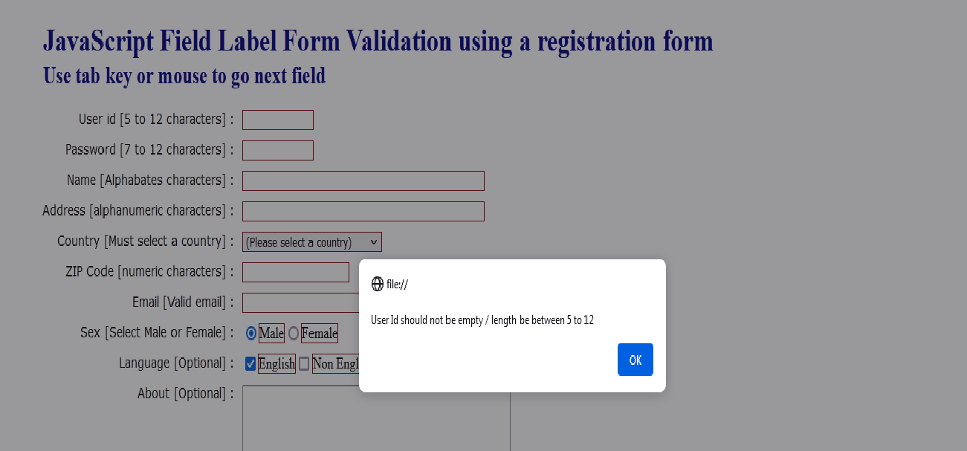

Example 3 Calculator
Embedded Javascript
Calc.html
<!-- Write a program to build the Calculator in JavaScript. -->
<!DOCTYPE html>
<html>
<head>
<title>
Calculator Program in JavaScript
</title>

<!-- Begins the JavaScript Code -->
<script>

// Use insert() function to insert the number in textview.
function insert(num)
{
document.form1.textview.value = document.form1.textview.value + num;
}

// Use equal() function to return the result based on passed values.
function equal()
{
var exp = document.form1.textview.value;
if(exp)
{
document.form1.textview.value = eval(exp)
}
}

/* Here, we create a backspace() function to remove the number at the end of the numeric series in textview. */
function backspace()
{
var exp = document.form1.textview.value;
document.form1.textview.value = exp.substring(0, exp.length - 1); /* remove the element from total length ? 1 */
}

</script>

<!-- Start the coding for CSS -->
<style>
/* Create the Outer layout of the Calculator. */
.formstyle
{
width: 450px;
height: 540px;
margin: 27px auto;
border: 9px solid skyblue;
border-radius: 5px;
padding: 20px;
text-align: center;
background-color: grey;
}

/* Display top horizontal bar that contain some information. */
h1 {
text-align: center;
padding: 23px;
background-color: skyblue;
color: white;
}
input:hover
{
background-color: green;
}

*{
margin: 0;
padding: 0;
}

/* It is used to create the layout for calculator button. */
.btn
{
width: 50px;
height: 50px;
font-size: 25px;
margin: 2px;
cursor: pointer;
background-color: red;
color: white;

}

/* It is used to display the numbers, operations and results. */
.textview
{
width: 223px;
margin: 5px;
font-size: 25px;
padding: 5px;
background-color: lightgreen;
}

</style>
</head>
<body>
<h1> Dynamic JavaScript Calculator using the HTML, CSS and JavaScript. </h1>
<div class= "formstyle">
<form name = "form1">
<input class= "textview" name = "textview">
</form>
<center>
<table >
<tr>
<td> <input class = "btn" type = "button" value = "C" onclick = "form1.textview.value = ' ' " > </td>
<td> <input class = "btn" type = "button" value = "B" onclick = "backspace()" > </td>
<td> <input class = "btn" type = "button" value = "/" onclick = "insert('/')" > </td>
<td> <input class = "btn" type = "button" value = "x" onclick = "insert('*')" > </td>
</tr>

<tr>
<td> <input class = "btn" type = "button" value = "7" onclick = "insert(7)" > </td>
<td> <input class = "btn" type = "button" value = "8" onclick = "insert(8)" > </td>
<td> <input class = "btn" type = "button" value = "9" onclick = "insert(9)" > </td>
<td> <input class = "btn" type = "button" value = "-" onclick = "insert('-')" > </td>
</tr>

<tr>
<td> <input class = "btn" type = "button" value = "4" onclick = "insert(4)" > </td>
<td> <input class = "btn" type = "button" value = "5" onclick = "insert(5)" > </td>
<td> <input class = "btn" type = "button" value = "6" onclick = "insert(6)" > </td>
<td> <input class = "btn" type = "button" value = "+" onclick = "insert('+')" > </td>
</tr>

<tr>
<td> <input class = "btn" type = "button" value = "1" onclick = "insert(1)" > </td>
<td> <input class = "btn" type = "button" value = "2" onclick = "insert(2)" > </td>
<td> <input class = "btn" type = "button" value = "3" onclick = "insert(3)" > </td>
<td rowspan = 5> <input class = "btn" style = "height: 110px" type = "button" value = "=" onclick = "equal()"> </td>
</tr>
<tr>
<td colspan = 2> <input class = "btn" style = "width: 106px" type = "button" value = "0" onclick = "insert(0)" > </td>
<td> <input class = "btn" type = "button" value = "." onclick = "insert('.')"> </td>
</tr>
</table>
</center>
</div>
</body>
</html>

Output Example 3

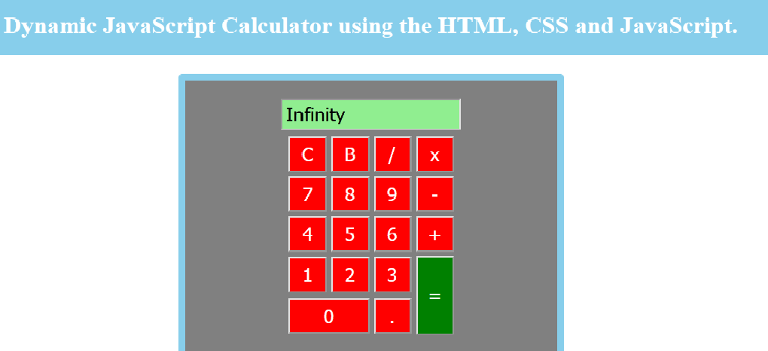

Assignment No. - 05
TITLE
JSP, Servlet and MySQL (Backend)
OBJECTIVES
- Understand about basic concepts of html, CSS

- Understand the basic functionalities of JSP

- Having the knowledge of SQL query to create the database
PROBLEM STATEMENTS
- Design and Build Student Login Page using JSP, Servlet and MySQL.
- Design and Build Employee Login Page using JSP, Servlet and MySQL.
OUTCOMES
Students will be able to,
- Develop a dynamic webpage using JSP, HTML and Servlet.

- Write a server side java application called Servlet to catch the data sent from client, process it and store it on database (MySQL).

- Write a server side java application called JSP to catch form data sent from client and store it on database (MySQL).
SOFTWARE NEEDED
- Any Operating System
- JDK 7or later
- Editors; Netbeans/Eclipse
- Web browser
- Tomcat 7 or later

THEORY - CONCEPT
Java Server Pages (JSP): It is a server side programming technology that is used to create dynamic web-based applications. JSP have right to use the complete Java APIs, including the JDBC API to access the databases.
It is a technology that helps software developers to create dynamic web pages based on HTML, XML and other document types. It was released in 1999 by Sun Microsystems. It is just like a PHP and ASP, but it uses the Java programming language.
A JSP element is a type of java servlet that is designed to accomplish the role of a user interface for a java web application. Web developers write JSPs as text files that combine HTML or XHTML code, XML elements, and rooted JSP actions and commands.
Using JSP, you can collect input from users through webpage forms, current records from a database or another source and create web pages dynamically.
JSP tags can be used for different purposes, such as retrieving information from a database or registering user preferences, accessing JavaBeans components, passing control between pages, and sharing information between requests, pages etc.
Why we need JSP?
JSP is used for the design of dynamic web page and servlet is used to code the logic that is present i.e. in the MVC (Model-View-Controller) architecture, the servlet is the controller and the JSP is the view.
Architecture of JSP
- The request / response part of a JSP is defined in below architecture

- The client initiated request for a JSP file using browser

- Webs server (i.e, JSP Engine) invokes the JSP file and interpret the JSP file produce a java code. The created java code will be a Servlet.

- Once Servlet is created, JSP engine compiles the servlet. Compilation errors will be detected in this phase.

- Now servlet class is loaded by the container and executes it.

- Engine sends the response back to the client.

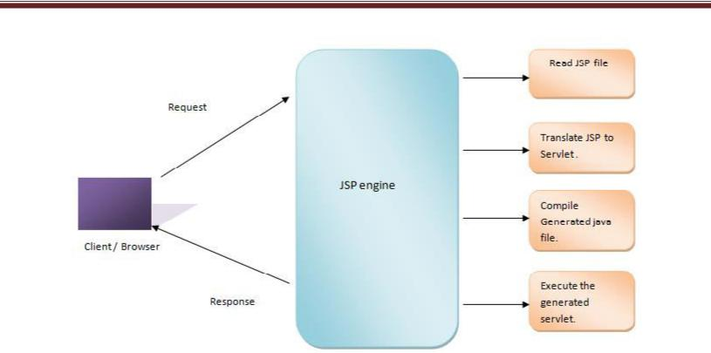

Figure.2: Architecture of JSP

Syntax of JSP:
JSP declarations is used to declare variables and methods as shown below,
<% text %>
Following is the simple and first example for JSP:
//Hello.jsp
<html>
<head>
<title> JSP File</title>
</head>
<body>
<%
out.println("Welcome to JSP Class");
%>
</body>
</html>
Output:
Welcome to JSP Class
Servlet:
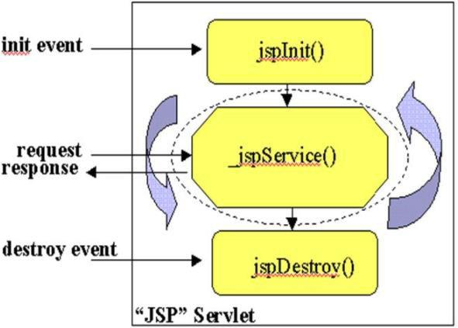
A Servlet is a server side program and written in Java. Servlet is a web component that is deployed on the server for creating the dynamic web pages. A Java servlet is a Java program that extends the capabilities of a server. Although servlets can respond to any types of requests, they most commonly execute applications hosted on Web servers.

Figure.3: Functions of Servlet

TECHNOLOGY/TOOL IN BRIEF
- JSP and Servlets
- IDE: NetBeans 7.0 or Later
- Databases: MySQL

NetBeans: NetBeans is an IDE, used for quickly and easily developing java desktop, mobile, and web applications, as well as HTML5 applications with HTML, JavaScript, and CSS. Also provides a huge set of tools for PHP and C/C++ developers. It is free and open source tool and has a great community of users and developers around the world.
MySQL: MySQL is a freely available open source Relational Database Management System (RDBMS). It uses the Structured Query Language (SQL).
SQL is the most popular language for adding, accessing and managing data in a database. It is most noted for its quick processing, proven reliability, ease and flexibility of use. MySQL is an essential part of almost every open source PHP application. Good examples for PHP & MySQL-based scripts are WordPress, Joomla, Magento and Drupal.
DESIGN / EXECUTION STEPS
Following steps are used to Create and Execute web applications,
- Design html and jsp files with an extension of.html and .jsp
- Write database connection page using servlet
- Set MySQL username, password and database name in database connection page
- Start the Tomcat Server with port number
- Open the browser and type localhost:8084
TEST CASES
Manual testing is used to validate the fields like username, password, mobile number and email id’s of the users entered by user with the database.
CONCLUSION / ANALYSIS
Hence, we have performed the dynamic web application using JSP, Servlet and MySQL.
PROGRAM CODE & OUTPUT
Following pages required to run this application:
- index.jsp
- SignUp.jsp
- User.jsp
- LoginSuccess.jsp
- LoginFailure.jsp
- LoginServlet.jsp
7. Login.jsp
- index.jsp <%--
Document : Login
Created on : Jan 29, 2018, 2:07:34 PM
Author : Admin --%>
<%@page contentType="text/html" pageEncoding="UTF-8"%> <!DOCTYPE html>
<html>
<head>
<meta http-equiv="Content-Type" content="text/html; charset=UTF-8"> <title> Login </title>
</head>
<body>
<table>
<tr>
<td width="300"></td>
<td> <font color="#339900" size="3.5">User Login</font> <table>
<tr>
<td>
<form id="user1" method="post" action="User.jsp" name="s" onSubmit="return
valid()">
<table border="2.0">
<tr>
<td>
User Id</td>
<td><input type="text" name="user1"></td>
</tr>
<tr>
<td>
Password</td>
<td><input type="password" name="pass"></td>
</tr>
<tr>
<td>

<center><input type="submit" name="user" value="Login"></center> </td>
</tr></table>
<center><table>
<tr>
<td>
<a href="SignUp.jsp"><font color="#000000" size="2"><b>New User?</b></font></a></td></tr></table>
</td>
</tr></table></center>
</td>
</tr>
</table>
</form>
</body>
</html>
//SignUp.jsp

<%@ page import="java.sql.*"%>

<%@ page import = "java.util.Date,java.text.SimpleDateFormat,java.text.ParseException"%> <%--

Document : SignUp
Created on : Jan 30, 2018, 11:52:03 PM
Author : Admin
--%>
<%@page contentType="text/html" pageEncoding="UTF-8"%>
<!DOCTYPE html>

<html>
<head>
<meta http-equiv="Content-Type" content="text/html; charset=UTF-8"> <title>JSP Page</title>
</head>
<body bgcolor="Skyblue">
<%
java.util.Date now = new java.util.Date();
String DATE_FORMAT1 = "dd/MM/yyyy";

SimpleDateFormat sdf1 = new SimpleDateFormat(DATE_FORMAT1); String strDateNew1 = sdf1.format(now);

%>
<table border="black" bgcolor=" black" align ="center" > <tr>
<td> <strong><em><font color="#990000" size="+1" face="Times New Roman" style="text-decoration:underline">User Registration</font></em></strong>
</td>
</tr>
</table>
<table border="black" align ="center">
<tr>
<td><form name="s" action="LoginServelt.jsp" method="get" onSubmit="return valid()">
<table align="center" cellpadding="6" cellspacing="6" width="400" height="300"> <td>
<tr>
<td><font face="Times New Roman" size="+1"><strong>Name</strong></font></td> <td>&nbsp;&nbsp;&nbsp;&nbsp; <input type="text" name="unn" class="b"></td>
</tr>
<tr>
<td><font face="Times New Roman" size="+1"><strong>User ID</strong></font></td> <td>&nbsp;&nbsp;&nbsp;&nbsp; <input type="text" name="uidd" id="name"></td>
</tr>
<tr>
<td><font face="Times New Roman" size="+1"><strong>Password</strong></font></td>
<td>&nbsp;&nbsp;&nbsp;&nbsp; <input type="password" name="passs" class="b"></td>
</tr>
<tr>
<td><font face="Times New Roman" size="+1"><strong>Mobile</strong></font></td> <td>&nbsp;&nbsp;&nbsp;&nbsp; <input type="text" name="mobb" class="b"></td>
</tr>
<tr>
<td><font face="Times New Roman" size="+1"><strong>Email ID</strong></font></td>
<td>&nbsp;&nbsp;&nbsp;&nbsp; <input type="text" name="eidd" class="b"></td>
</tr>
<tr>

<td><font face="Times New Roman" size="+1"><strong>Date</strong></font></td> <td>&nbsp;&nbsp;&nbsp;&nbsp; <input type="text" name="date" class="b" value="<%=strDateNew1%>"></td>
</tr>
<tr>
<td></td>

<td>&nbsp;&nbsp;&nbsp;&nbsp; <input type="submit" name="s" value="submit" class="b1" >

&nbsp;&nbsp;&nbsp; <input type="reset" name="r" value="clear" class="b1"></td> </tr></td>

<td></td>
</table>
</form></td>
</tr></table>
<center> <table><tr><td> <a href="index.jsp"><font color="#000000" size="2"><b>Login Here</b></font></a>
</td>
</tr></table></center>
</body>
</html>

//LoginSuccess.jsp

<%--
Document : LoginSuccess
Created on : Jan 31, 2018, 2:40:04 PM
Author : Admin
--%>

<%@page contentType="text/html" pageEncoding="UTF-8"%>
<!DOCTYPE html>
<html>
<head>

<meta http-equiv="Content-Type" content="text/html; charset=UTF-8"> <title>JSP Page</title>

</head>
<body>
<h1> User Logged In Successfully!...</h1>
</body>

</html>
//LoginFailure.jsp
<%--
Document : LoginFailure
Created on : Jan 31, 2018, 2:42:21 PM
Author : Admin
--%>
<%@page contentType="text/html" pageEncoding="UTF-8"%>
<!DOCTYPE html>
<html>
<head>

<meta http-equiv="Content-Type" content="text/html; charset=UTF-8"> <title>JSP Page</title>

</head>
<body>

<h1> <font color="Red"> Please Provide Correct Username or Password!..Retry Again!.. </font> </h1>

<table>
<tr>
<td>
<form id="user1" method="post" action="User.jsp" name="s" onSubmit="return
valid()">

<table>
<tr>
<td>
User Id</td>
<td><input type="text" name="user1"></td>
</tr>
<tr>
<td>
Password</td>
<td><input type="password" name="pass"></td>
</tr>
<tr>
<td>
</td>
<td>

<input type="submit" name="user" value="Login"></td> </tr></table>

</form>
</td>
</tr></table>
</body>
</html>
//LoginServlet.jsp
<%@page import="java.sql.*"%>
<%@ page import="java.io.*"%>
<%@ page import = "java.util.Date,java.text.SimpleDateFormat,java.text.ParseException"%>
<%
String a = request.getParameter("uidd");
String x = request.getParameter("unn");
String b = request.getParameter("passs");
String c = request.getParameter("mobb");
String d = request.getParameter("eidd");
session.setAttribute("d",d);

//String f=request.getParameter("date");
//out.print(strDateNew1);
//out.print(x);
//out.print(b);
//out.print(c);
//out.print(d);
//out.print(f);
java.util.Date now = new java.util.Date();

String DATE_FORMAT = "yyyy-MM-dd";

SimpleDateFormat sdf = new SimpleDateFormat(DATE_FORMAT); String strDateNew = sdf.format(now) ; //response.sendRedirect("signup.jsp?message=success"); //String userid=null;
//String m="avl";
try
{
Class.forName("com.mysql.jdbc.Driver");
Connection con =
DriverManager.getConnection("jdbc:mysql://localhost:3306/loginpage","root","root");
PreparedStatement ps=con.prepareStatement("insert into
student(sname,suserid,spass,mobile,email,date) values(?,?,?,?,?,'"+strDateNew+"')");
//ResultSet rs=ps.executeQuery();
ps.setString(1,x);
ps.setString(2,a);
ps.setString(3,b);
ps.setString(4,c);

ps.setString(5,d);
ps.executeUpdate();
response.sendRedirect("SignUp.jsp?success");
}
catch(Exception e1)
{
out.println(e1.getMessage());
response.sendRedirect("SignUp.jsp?Failure");%>
}

%>

//User.jsp

<%@ page import="java.sql.*;"%>
<%

String a=request.getParameter("user1");
String b=request.getParameter("pass");
String id=null,name=null,userid=null,email=null;
try{
Class.forName("com.mysql.jdbc.Driver");
Connection con =
DriverManager.getConnection("jdbc:mysql://localhost:3306/loginpage","root","root");
//Connection con = databasecon.getconnection();
PreparedStatement ps=con.prepareStatement("select sid,sname,suserid,email from student where
suserid='"+a+"' && spass='"+b+"'");
ResultSet rs=ps.executeQuery();
if(rs.next())
{
id=rs.getString("sid");
name=rs.getString("sname");
userid=rs.getString("suserid");
email=rs.getString("email");
session.setAttribute("sid",id);
session.setAttribute("sname",name);
session.setAttribute("suserid",userid);
session.setAttribute("email",email);
//response.sendRedirect("user5.jsp");
response.sendRedirect("LoginSuccess.jsp?Success");
//out.print(name2);

}
else
{
response.sendRedirect("LoginFailure.jsp?Failure");
}
}
catch(Exception e2){
out.println(e2.getMessage());
}
%>

//Database Name: loginpage
//Table Name: student
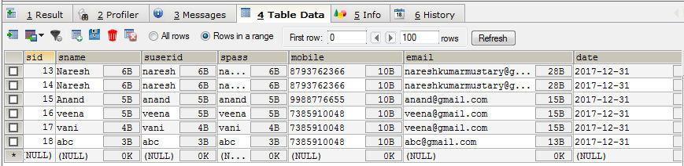

Output:
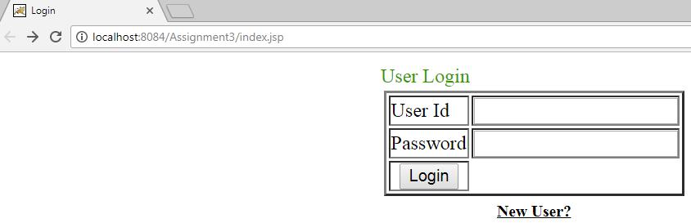
Step 1: Run index.jsp page

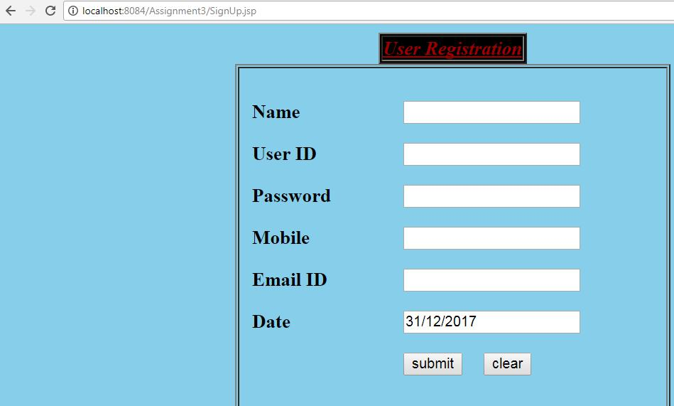

Step 3: Once registered click Login directly

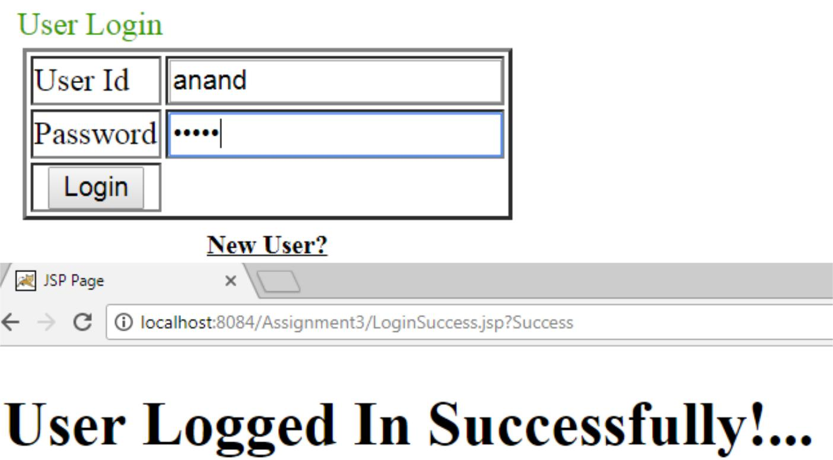

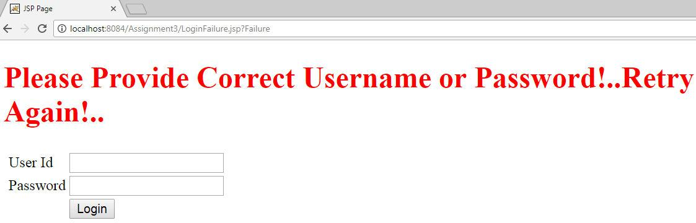

ORAL QUESTIONS

- What is JSP?
- What is Servlet?
- What is the purpose of MySQL?
- What is database?
- What is the syntax of JSP?
- How do we connect JSP file to database?

Assignment No. - 06
TITLE
Implement Sample Program demonstrating use of Servlet.
OBJECTIVES
- Understand the working of Servlet.
- Connecting MySQL database with Servlet
PROBLEM STATEMENTS
Design and build employee system in Servlet.
OUTCOMES
Students will be able to,
- Develop a dynamic webpage using JSP, HTML and Servlet.

- Write a server side java application called Servlet to catch the data sent from client, process it and store it on database (MySQL).

- Write a server side java application called JSP to catch form data sent from client and store it on database (MySQL).
SOFTWARE NEEDED
- Any Operating System
- JDK 7or later
- Editors; Netbeans/Eclipse
- Web browser
- Tomcat 7 or later

THEORY - CONCEPT
Servlet- Servlets are the Java programs that run on the Java-enabled web server or application server. They are used to handle the request obtained from the webserver, process the request, produce the response then, send a response back to the webserver.
Properties of Servlets are as follows:
- Servlets work on the server-side.
- Servlets are capable of handling complex requests obtained from the webserver.
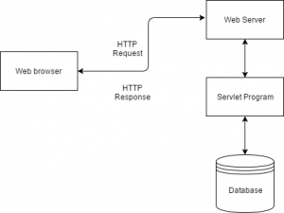
Fig. Architecture of Servlet
Execution of Servlets basically involves six basic steps:
- The clients send the request to the webserver.
- The web server receives the request.
- The web server passes the request to the corresponding servlet.
- The servlet processes the request and generates the response in the form of output.
- The servlet sends the response back to the webserver.
- The web server sends the response back to the client and the client browser displays it on the screen.

Advantages of a Java Servlet
- Servlet is faster than CGI as it doesn’t involve the creation of a new process for every new request received.
- Servlets, as written in Java, are platform-independent.
- Removes the overhead of creating a new process for each request as Servlet doesn’t run in a separate process. There is only a single instance that handles all requests concurrently. This also saves the memory and allows a Servlet to easily manage the client state.
- It is a server-side component, so Servlet inherits the security provided by the Web server.
- The API designed for Java Servlet automatically acquires the advantages of the Java platforms such as platform-independent and portability. In addition, it obviously can use the wide range of APIs created on Java platforms such as JDBC to access the database.

Steps-
1. Create MySQL database and tables.
2. Create HTML page.
3. Add tomcat server to eclipse project.
4. Add all the required jar files.
5. Create a servlet program.
- Import all the packages
- Register the JDBC Driver
- Open a connection
- Execute the query, and retrieve the result
- Clean up the JDBC Environment
6. Run the project on Apache Server.

details.jsp
<%@ page language="java" contentType="text/html; charset=ISO-8859-1" pageEncoding="ISO-8859-1"%>
<!DOCTYPE html>
<html>
<head>
<meta charset="ISO-8859-1">
<title>Student details</title>
<style>
table, tr, td
{
border: 1px solid black;
}
table
{
margin-left:25%;
width:50%;
}
.cent
{
text-align: center;
}
</style>
</head>
<body style="background:#e4f578;">
<%@page import="java.sql.*"%>
<div class="cent">
<h1>Student Details</h1><br/>
<%
try
{
Class.forName("com.mysql.jdbc.Driver");
Connection con=DriverManager.getConnection("jdbc:mysql://localhost:3306/wt","root","root");
Statement stmt=con.createStatement();
ResultSet rs=stmt.executeQuery("select * from student");
%>
<table>
<tr style="background-color:#071966;color:#fff;">
<td>Roll No</td>
<td>Name</td>
<td>Address</td>
<td>Percentage</td>
<td>DOB</td>
</tr>
<%
while(rs.next())
{
%>
<tr>
<td><%=rs.getInt(1) %></td>
<td><%=rs.getString(2) %></td>
<td><%=rs.getString(3) %></td>
<td><%=rs.getString(4) %></td>
<td><%=rs.getString(5) %></td>
</tr>
<%
}
}
catch(Exception e)
{
out.println(e);
}
%>
</table>
</div>
</body>
</html>
Output
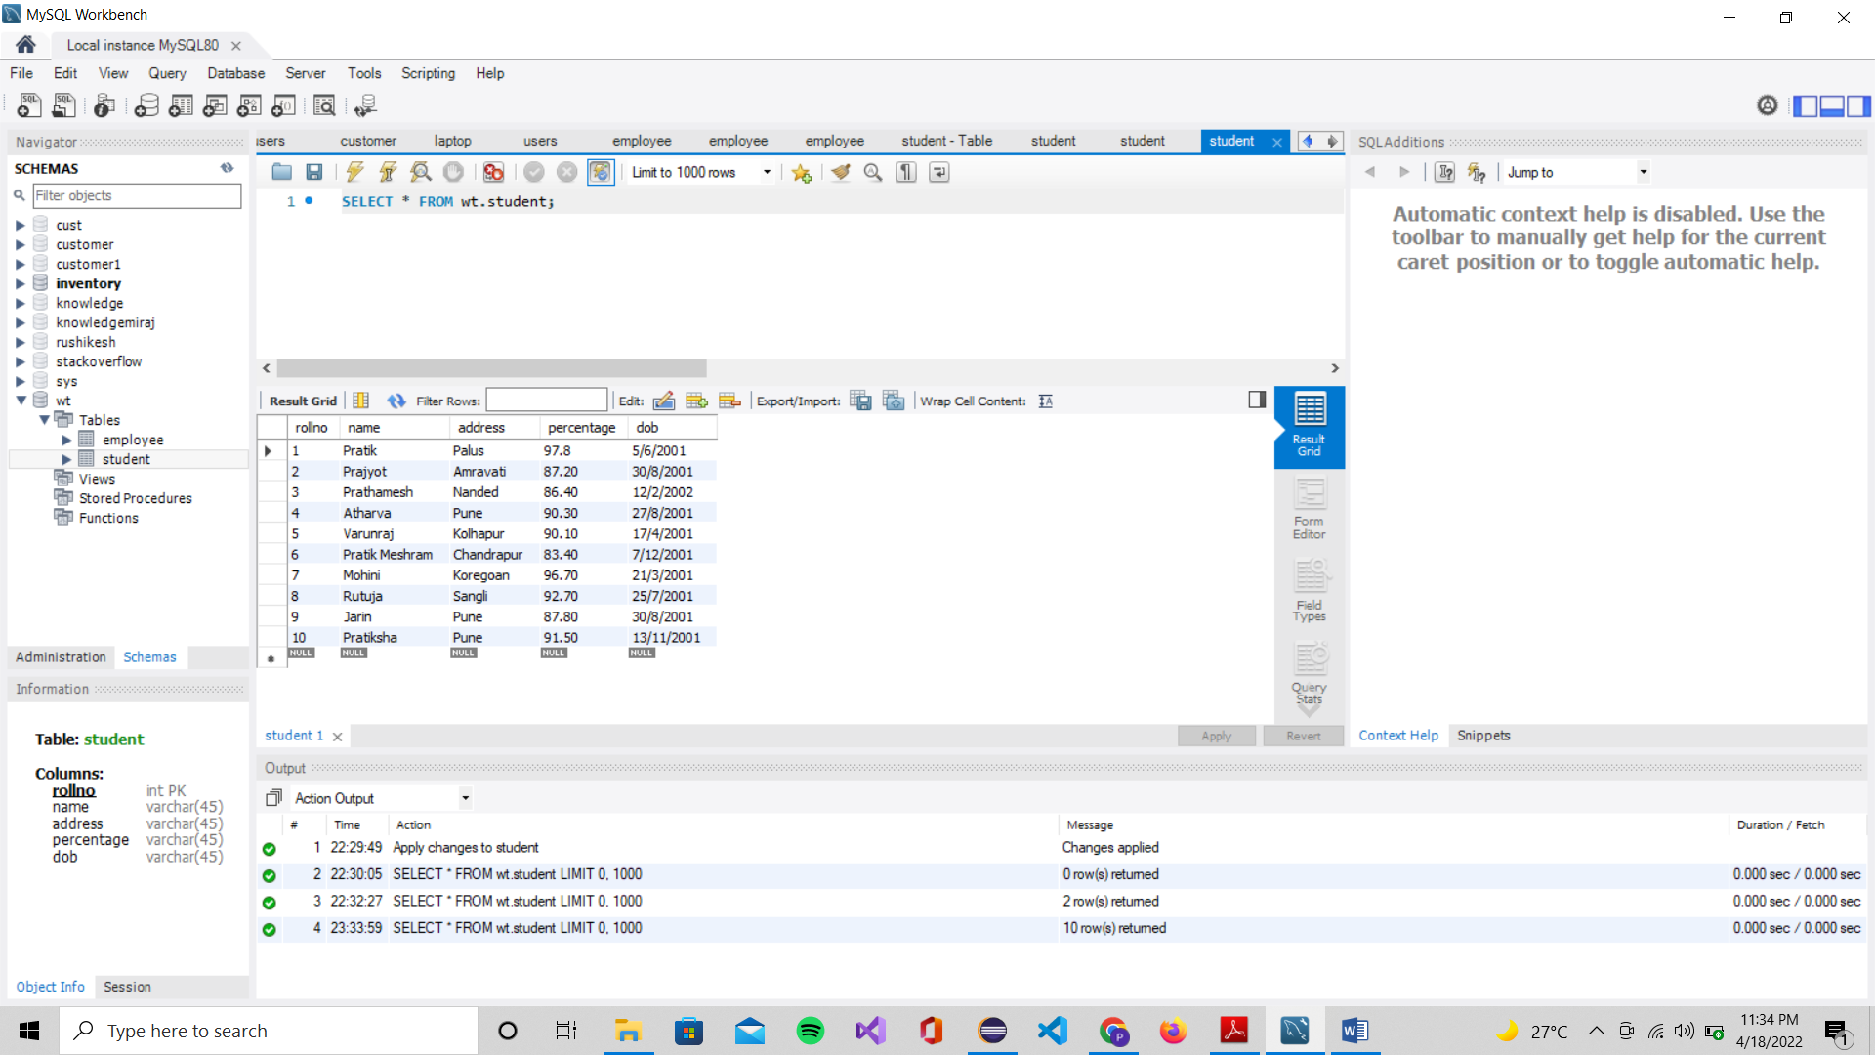
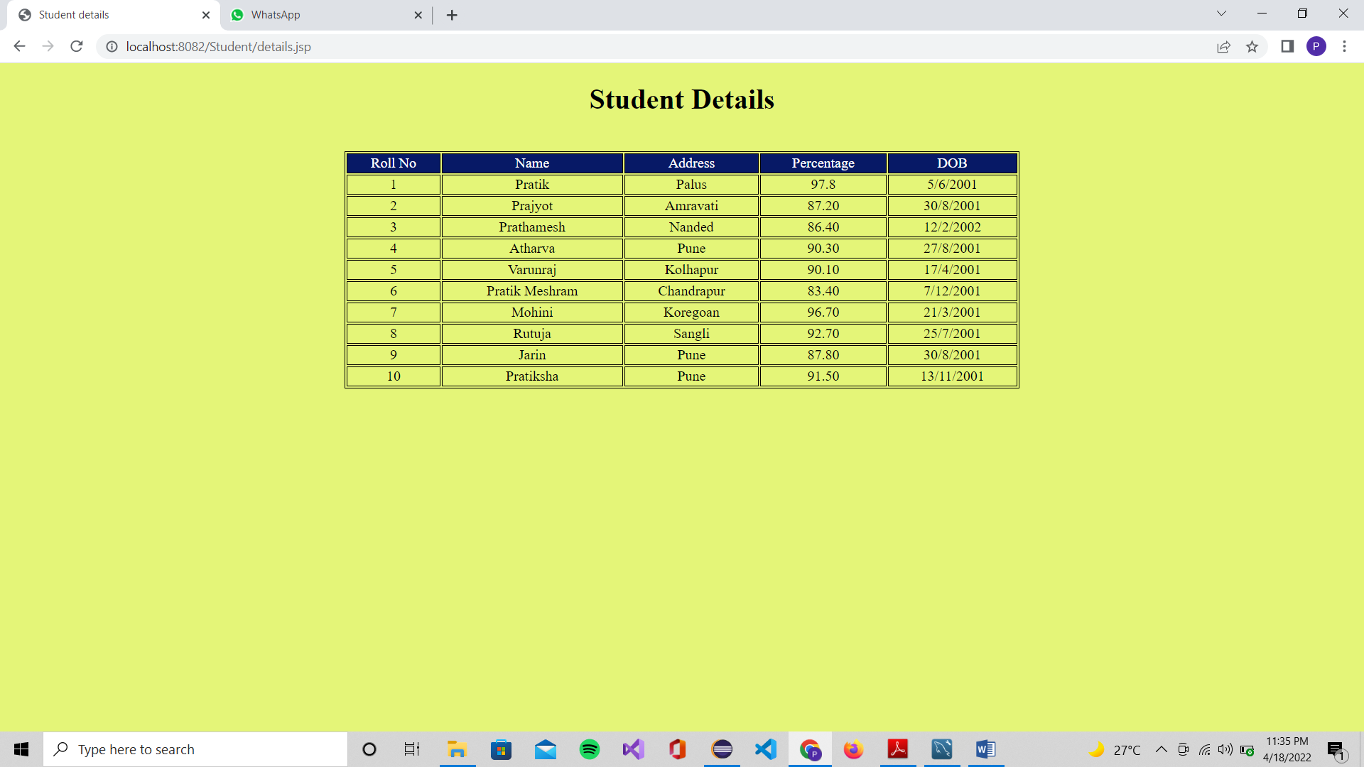

Assignment No. - 07
TITLE
Implement Sample Program demonstrating CRUD operations in PHP.
OBJECTIVES
  - Understand the working of PHP.
  - Connecting MySQL database with PHP.
PROBLEM STATEMENTS
Design and build employee system in PHP and MySQL.
OUTCOMES
Students will be able to,
- Develop a dynamic webpage using PHP, HTML and MySQL.

- Write a server side PHP to catch the data sent from client, process it and store it on database (MySQL).
SOFTWARE NEEDED
- Any Operating System
- JDK 7or later
- Editors; Netbeans/Eclipse
- Web browser
- Tomcat 7 or later

THEORY - CONCEPT
PHP- PHP is a server scripting language, and a powerful tool for making dynamic and interactive Web pages.
PHP is a widely-used, free, and efficient alternative to competitors such as Microsoft's ASP.
- PHP is an acronym for "PHP: Hypertext Preprocessor"
- PHP is a widely-used, open source scripting language
- PHP scripts are executed on the server
- PHP is free to download and use
Working
The PHP programme interacts with the site server, which is the programme that sends out web pages to the rest of the world. When you type a URL into the address bar of your web browser, you’re telling the web server at that URL to email you an HTML file. The requested file is sent by the web server in response. The HTML file is read by your browser, and then shows the web page. When you press a source on a web page, you’re also requesting a file from the web server. Additionally, when you press a web page button that submits a form, the web server processes a file. When PHP is mounted, the procedure is exactly the same. You submit a file, and the web server, which happens to be running PHP, responds with HTML, because of PHP it all happens.

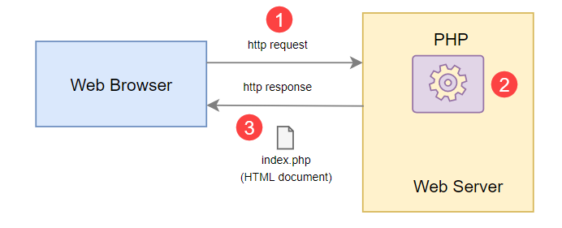
Fig. Working of PHP
Code
1. index.php
<!DOCTYPE html>
<html lang="en">
<head>
<meta charset="UTF-8">
<title>Dashboard</title>
<link rel="stylesheet" href="https://stackpath.bootstrapcdn.com/bootstrap/4.5.2/css/bootstrap.min.css">
<link rel="stylesheet" href="https://maxcdn.bootstrapcdn.com/font-awesome/4.7.0/css/font-awesome.min.css">
<script src="https://code.jquery.com/jquery-3.5.1.min.js"></script>
<script src="https://cdn.jsdelivr.net/npm/popper.js@1.16.1/dist/umd/popper.min.js"></script>
<script src="https://stackpath.bootstrapcdn.com/bootstrap/4.5.2/js/bootstrap.min.js"></script>
<style>
.wrapper{
width: 600px;
margin: 0 auto;
}
table tr td:last-child{
width: 120px;
}
</style>
<script>
$(document).ready(function(){
$('[data-toggle="tooltip"]').tooltip();
});
</script>
</head>
<body>
<div class="wrapper">
<div class="container-fluid">
<div class="row">
<div class="col-md-12">
<div class="mt-5 mb-3 clearfix">
<h2 class="pull-left">Employees Details</h2>
<a href="create.php" class="btn btn-success pull-right"><i class="fa fa-plus"></i> Add New Employee</a>
</div>
<?php
// Include config file
require_once "config.php";
$sql = "SELECT * FROM employees";
if($result = mysqli_query($link, $sql)){
if(mysqli_num_rows($result) > 0){
echo '<table class="table table-bordered table-striped">';
echo "<thead>";
echo "<tr>";
echo "<th>#</th>";
echo "<th>Name</th>";
echo "<th>Address</th>";
echo "<th>Salary</th>";
echo "<th>Action</th>";
echo "</tr>";
echo "</thead>";
echo "<tbody>";
while($row = mysqli_fetch_array($result)){
echo "<tr>";
echo "<td>" . $row['id'] . "</td>";
echo "<td>" . $row['name'] . "</td>";
echo "<td>" . $row['address'] . "</td>";
echo "<td>" . $row['salary'] . "</td>";
echo "<td>";
echo '<a href="read.php?id='. $row['id'] .'" class="mr-3" title="View Record" data-toggle="tooltip"><span class="fa fa-eye"></span></a>';
echo '<a href="update.php?id='. $row['id'] .'" class="mr-3" title="Update Record" data-toggle="tooltip"><span class="fa fa-pencil"></span></a>';
echo '<a href="delete.php?id='. $row['id'] .'" title="Delete Record" data-toggle="tooltip"><span class="fa fa-trash"></span></a>';
echo "</td>";
echo "</tr>";
}
echo "</tbody>";
echo "</table>";
mysqli_free_result($result);
} else{
echo '<div class="alert alert-danger"><em>No records were found.</em></div>';
}
} else{
echo "Oops! Something went wrong. Please try again later.";
}
mysqli_close($link);
?>
</div>
</div>
</div>
</div>
</body>
</html>

2. config.php
<?php
define('DB_SERVER', 'localhost');
define('DB_USERNAME', 'root');
define('DB_PASSWORD', '');
define('DB_NAME', 'wt');
$link = mysqli_connect(DB_SERVER, DB_USERNAME, DB_PASSWORD, DB_NAME);
if($link === false){
die("ERROR: Could not connect. " . mysqli_connect_error());
}
?>

3. create.php
<?php
// Include config file
require_once "config.php";
$name = $address = $salary = "";
$name_err = $address_err = $salary_err = "";
if($_SERVER["REQUEST_METHOD"] == "POST"){
// Validate name
$input_name = trim($_POST["name"]);
if(empty($input_name)){
$name_err = "Please enter a name.";
} elseif(!filter_var($input_name, FILTER_VALIDATE_REGEXP, array("options"=>array("regexp"=>"/^[a-zA-Z\s]+$/")))){
$name_err = "Please enter a valid name.";
} else{
$name = $input_name;
}
$input_address = trim($_POST["address"]);
if(empty($input_address)){
$address_err = "Please enter an address.";
} else{
$address = $input_address;
}
$input_salary = trim($_POST["salary"]);
if(empty($input_salary)){
$salary_err = "Please enter the salary amount.";
} elseif(!ctype_digit($input_salary)){
$salary_err = "Please enter a positive integer value.";
} else{
$salary = $input_salary;
}
if(empty($name_err) && empty($address_err) && empty($salary_err)){
$sql = "INSERT INTO employees (name, address, salary) VALUES (?, ?, ?)";
if($stmt = mysqli_prepare($link, $sql)){
mysqli_stmt_bind_param($stmt, "sss", $param_name, $param_address, $param_salary);
$param_name = $name;
$param_address = $address;
$param_salary = $salary;
if(mysqli_stmt_execute($stmt)){
header("location: index.php");
exit();
} else{
echo "Oops! Something went wrong. Please try again later.";
}
}
mysqli_stmt_close($stmt);
}
mysqli_close($link);
}
?>
<!DOCTYPE html>
<html lang="en">
<head>
<meta charset="UTF-8">
<title>Create Record</title>
<link rel="stylesheet" href="https://stackpath.bootstrapcdn.com/bootstrap/4.5.2/css/bootstrap.min.css">
<style>
.wrapper{
width: 600px;
margin: 0 auto;
}
</style>
</head>
<body>
<div class="wrapper">
<div class="container-fluid">
<div class="row">
<div class="col-md-12">
<h2 class="mt-5">Create Record</h2>
<p>Please fill this form and submit to add employee record to the database.</p>
<form action="<?php echo htmlspecialchars($_SERVER["PHP_SELF"]); ?>" method="post">
<div class="form-group">
<label>Name</label>
<input type="text" name="name" class="form-control <?php echo (!empty($name_err)) ? 'is-invalid' : ''; ?>" value="<?php echo $name; ?>">
<span class="invalid-feedback"><?php echo $name_err;?></span>
</div>
<div class="form-group">
<label>Address</label>
<textarea name="address" class="form-control <?php echo (!empty($address_err)) ? 'is-invalid' : ''; ?>"><?php echo $address; ?></textarea>
<span class="invalid-feedback"><?php echo $address_err;?></span>
</div>
<div class="form-group">
<label>Salary</label>
<input type="text" name="salary" class="form-control <?php echo (!empty($salary_err)) ? 'is-invalid' : ''; ?>" value="<?php echo $salary; ?>">
<span class="invalid-feedback"><?php echo $salary_err;?></span>
</div>
<input type="submit" class="btn btn-primary" value="Submit">
<a href="index.php" class="btn btn-secondary ml-2">Cancel</a>
</form>
</div>
</div>
</div>
</div>
</body>
</html>

4. delete.php
<?php
if(isset($_POST["id"]) && !empty($_POST["id"])){
require_once "config.php";
$sql = "DELETE FROM employees WHERE id = ?";
if($stmt = mysqli_prepare($link, $sql)){
mysqli_stmt_bind_param($stmt, "i", $param_id);
$param_id = trim($_POST["id"]);
if(mysqli_stmt_execute($stmt)){
header("location: index.php");
exit();
} else{
echo "Oops! Something went wrong. Please try again later.";
}
}
mysqli_stmt_close($stmt);
mysqli_close($link);
} else{
if(empty(trim($_GET["id"]))){
header("location: error.php");
exit();
}
}
?>
<!DOCTYPE html>
<html lang="en">
<head>
<meta charset="UTF-8">
<title>Delete Record</title>
<link rel="stylesheet" href="https://stackpath.bootstrapcdn.com/bootstrap/4.5.2/css/bootstrap.min.css">
<style>
.wrapper{
width: 600px;
margin: 0 auto;
}
</style>
</head>
<body>
<div class="wrapper">
<div class="container-fluid">
<div class="row">
<div class="col-md-12">
<h2 class="mt-5 mb-3">Delete Record</h2>
<form action="<?php echo htmlspecialchars($_SERVER["PHP_SELF"]); ?>" method="post">
<div class="alert alert-danger">
<input type="hidden" name="id" value="<?php echo trim($_GET["id"]); ?>"/>
<p>Are you sure you want to delete this employee record?</p>
<p>
<input type="submit" value="Yes" class="btn btn-danger">
<a href="index.php" class="btn btn-secondary">No</a>
</p>
</div>
</form>
</div>
</div>
</div>
</div>
</body>
</html>

5. update.php
<?php
require_once "config.php";
$name = $address = $salary = "";
$name_err = $address_err = $salary_err = "";
if(isset($_POST["id"]) && !empty($_POST["id"])){
$id = $_POST["id"];
$input_name = trim($_POST["name"]);
if(empty($input_name)){
$name_err = "Please enter a name.";
} elseif(!filter_var($input_name, FILTER_VALIDATE_REGEXP, array("options"=>array("regexp"=>"/^[a-zA-Z\s]+$/")))){
$name_err = "Please enter a valid name.";
} else{
$name = $input_name;
}
$input_address = trim($_POST["address"]);
if(empty($input_address)){
$address_err = "Please enter an address.";
} else{
$address = $input_address;
}
$input_salary = trim($_POST["salary"]);
if(empty($input_salary)){
$salary_err = "Please enter the salary amount.";
} elseif(!ctype_digit($input_salary)){
$salary_err = "Please enter a positive integer value.";
} else{
$salary = $input_salary;
}
if(empty($name_err) && empty($address_err) && empty($salary_err)){
$sql = "UPDATE employees SET name=?, address=?, salary=? WHERE id=?";
if($stmt = mysqli_prepare($link, $sql)){
mysqli_stmt_bind_param($stmt, "sssi", $param_name, $param_address, $param_salary, $param_id);
$param_name = $name;
$param_address = $address;
$param_salary = $salary;
$param_id = $id;
if(mysqli_stmt_execute($stmt)){
header("location: index.php");
exit();
} else{
echo "Oops! Something went wrong. Please try again later.";
}
}
mysqli_stmt_close($stmt);
}
mysqli_close($link);
} else{
if(isset($_GET["id"]) && !empty(trim($_GET["id"]))){
$id = trim($_GET["id"]);
$sql = "SELECT * FROM employees WHERE id = ?";
if($stmt = mysqli_prepare($link, $sql)){
mysqli_stmt_bind_param($stmt, "i", $param_id);
$param_id = $id;
if(mysqli_stmt_execute($stmt)){
$result = mysqli_stmt_get_result($stmt);
if(mysqli_num_rows($result) == 1){
$row = mysqli_fetch_array($result, MYSQLI_ASSOC);
$name = $row["name"];
$address = $row["address"];
$salary = $row["salary"];
} else{
// URL doesn't contain valid id. Redirect to error page
header("location: error.php");
exit();
}
} else{
echo "Oops! Something went wrong. Please try again later.";
}
}
mysqli_stmt_close($stmt);
mysqli_close($link);
} else{
// URL doesn't contain id parameter. Redirect to error page
header("location: error.php");
exit();
}
}
?>
<!DOCTYPE html>
<html lang="en">
<head>
<meta charset="UTF-8">
<title>Update Record</title>
<link rel="stylesheet" href="https://stackpath.bootstrapcdn.com/bootstrap/4.5.2/css/bootstrap.min.css">
<style>
.wrapper{
width: 600px;
margin: 0 auto;
}
</style>
</head>
<body>
<div class="wrapper">
<div class="container-fluid">
<div class="row">
<div class="col-md-12">
<h2 class="mt-5">Update Record</h2>
<p>Please edit the input values and submit to update the employee record.</p>
<form action="<?php echo htmlspecialchars(basename($_SERVER['REQUEST_URI'])); ?>" method="post">
<div class="form-group">
<label>Name</label>
<input type="text" name="name" class="form-control <?php echo (!empty($name_err)) ? 'is-invalid' : ''; ?>" value="<?php echo $name; ?>">
<span class="invalid-feedback"><?php echo $name_err;?></span>
</div>
<div class="form-group">
<label>Address</label>
<textarea name="address" class="form-control <?php echo (!empty($address_err)) ? 'is-invalid' : ''; ?>"><?php echo $address; ?></textarea>
<span class="invalid-feedback"><?php echo $address_err;?></span>
</div>
<div class="form-group">
<label>Salary</label>
<input type="text" name="salary" class="form-control <?php echo (!empty($salary_err)) ? 'is-invalid' : ''; ?>" value="<?php echo $salary; ?>">
<span class="invalid-feedback"><?php echo $salary_err;?></span>
</div>
<input type="hidden" name="id" value="<?php echo $id; ?>"/>
<input type="submit" class="btn btn-primary" value="Submit">
<a href="index.php" class="btn btn-secondary ml-2">Cancel</a>
</form>
</div>
</div>
</div>
</div>
</body>
</html>

6. read.php
<?php
if(isset($_GET["id"]) && !empty(trim($_GET["id"]))){
require_once "config.php";
$sql = "SELECT * FROM employees WHERE id = ?";

if($stmt = mysqli_prepare($link, $sql)){
mysqli_stmt_bind_param($stmt, "i", $param_id);
$param_id = trim($_GET["id"]);
if(mysqli_stmt_execute($stmt)){
$result = mysqli_stmt_get_result($stmt);
if(mysqli_num_rows($result) == 1){
$row = mysqli_fetch_array($result, MYSQLI_ASSOC);
$name = $row["name"];
$address = $row["address"];
$salary = $row["salary"];
} else{
header("location: error.php");
exit();
}
} else{
echo "Oops! Something went wrong. Please try again later.";
}
}
mysqli_stmt_close($stmt);
mysqli_close($link);
} else{
// URL doesn't contain id parameter. Redirect to error page
header("location: error.php");
exit();
}
?>
<!DOCTYPE html>
<html lang="en">
<head>
<meta charset="UTF-8">
<title>View Record</title>
<link rel="stylesheet" href="https://stackpath.bootstrapcdn.com/bootstrap/4.5.2/css/bootstrap.min.css">
<style>
.wrapper{
width: 600px;
margin: 0 auto;
}
</style>
</head>
<body>
<div class="wrapper">
<div class="container-fluid">
<div class="row">
<div class="col-md-12">
<h1 class="mt-5 mb-3">View Record</h1>
<div class="form-group">
<label>Name</label>
<p><b><?php echo $row["name"]; ?></b></p>
</div>
<div class="form-group">
<label>Address</label>
<p><b><?php echo $row["address"]; ?></b></p>
</div>
<div class="form-group">
<label>Salary</label>
<p><b><?php echo $row["salary"]; ?></b></p>
</div>
<p><a href="index.php" class="btn btn-primary">Back</a></p>
</div>
</div>
</div>
</div>
</body>
</html>
Output

Assignment No. - 08
TITLE
Design and implement login page using Struts.
OBJECTIVES
- Understand the working of Struts.
- Perform validations using Struts2.

PROBLEM STATEMENTS
Design and build login page with necessary validations using Struts.
OUTCOMES
Students will be able to,
- Develop a dynamic webpage using Stuts2 framework.

- Write a program to create validations using Struts2.
SOFTWARE NEEDED
- Any Operating System
- JDK 7or later
- Editors; Netbeans/Eclipse
- Web browser
- Tomcat 7 or later

THEORY – CONCEPT
The struts 2 framework is used to develop MVC-based web application.
The struts framework was initially created by Craig McClanahan and donated to Apache Foundation in May, 2000 and Struts 1.0 was released in June 2001.
The Struts 2 framework is used to develop MVC (Model View Controller) based web applications. Struts 2 is the combination of webwork framework of opensymphony and struts 1.
struts2 = webwork + struts1
The Struts 2 provides supports to POJO based actions, Validation Support, AJAX Support, Integration support to various frameworks such as Hibernate, Spring, Tiles etc, support to various result types such as Freemarker, Velocity, JSP etc.
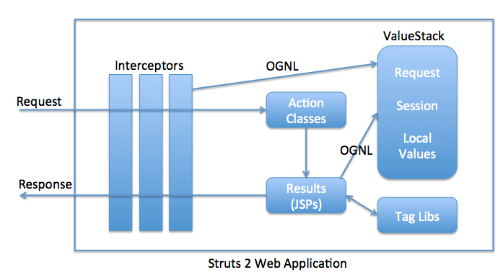
Fig. Struts2 Web Application
Code
1. index.html
<!DOCTYPE html>
<html>
<head>
<meta charset="UTF-8">
<title>Login</title>
</head>
<body>
<form action="hello.action">
Enter Name: <input type="text" name="uname"><br/>
Enter Password: <input type="password" name="password"><br/>
<input type="submit" name="Submit">
</form>
</body>
</html>
2. error.jsp
<%@ page language="java" contentType="text/html; charset=UTF-8"
pageEncoding="UTF-8"%>
<!DOCTYPE html>
<html>
<head>
<meta charset="UTF-8">
<title>Error File</title>
</head>
<body>
Invalid Credentials!!!
</body>
</html>
3. results.jsp
<%@ page language="java" contentType="text/html; charset=UTF-8"
pageEncoding="UTF-8"%>
<%@taglib prefix="s" uri="/struts-tags" %>
<!DOCTYPE html>
<html>
<head>
<meta charset="UTF-8">
<title>Result</title>
</head>
<body>
Hello <s:property value="uname" /> !!!
</body>
</html>
4. HelloAction.java
package com.ncnz.struts;

import org.apache.struts2.convention.annotation.Action;
import org.apache.struts2.convention.annotation.Result;
import org.apache.struts2.convention.annotation.Results;

@Action("/hello")
@Results({
@Result(name = "success", location = "/results.jsp"),
@Result(name = "error", location = "/error.jsp")
})
public class HelloAction {
private String uname;
private String password;
public String execute() {
if(uname.equals("pratik") && password.equals("1234"))
{
return "success";
}
else
return "error";
}
public String getUname() {
return uname;
}
public void setUname(String uname) {
this.uname = uname;
}
public String getPassword() {
return password;
}
public void setPassword(String password) {
this.password = password;
}

}

5. web.xml
<?xml version="1.0" encoding="UTF-8"?>
<web-app xmlns:xsi="https://www.w3.org/2001/XMLSchema-instance"
xmlns="http://java.sun.com/xml/ns/javaee"
xsi:schemaLocation="http://java.sun.com/xml/ns/javaee http://java.sun.com/xml/ns/javaee/web-app_3_0.xsd"
id="apache-struts-config-example">

<display-name>Example Not Struts Config XML</display-name>
<filter>
<filter-name>struts2</filter-name>
<filter-class>org.apache.struts2.dispatcher.filter.StrutsPrepareAndExecuteFilter</filter-class>
</filter>
<filter-mapping>
<filter-name>struts2</filter-name>
<url-pattern>/*</url-pattern>
</filter-mapping>
</web-app>
6. pom.xml
<project xmlns="http://maven.apache.org/POM/4.0.0" xmlns:xsi="http://www.w3.org/2001/XMLSchema-instance" xsi:schemaLocation="http://maven.apache.org/POM/4.0.0 https://maven.apache.org/xsd/maven-4.0.0.xsd">
<modelVersion>4.0.0</modelVersion>
<groupId>com.ncnz</groupId>
<artifactId>struts-example</artifactId>
<version>0.0.1-SNAPSHOT</version>
<packaging>war</packaging>
<dependencies>
<dependency>
<groupId>org.apache.struts</groupId>
<artifactId>struts2-core</artifactId>
<version>2.5.5</version>
</dependency>
<dependency>
<groupId>org.apache.struts</groupId>
<artifactId>struts2-convention-plugin</artifactId>
<version>2.5.10</version>
</dependency>
<dependency>
<groupId>javax.servlet</groupId>
<artifactId>javax.servlet-api</artifactId>
<version>3.1.0</version>
</dependency>
</dependencies>
</project>

Output
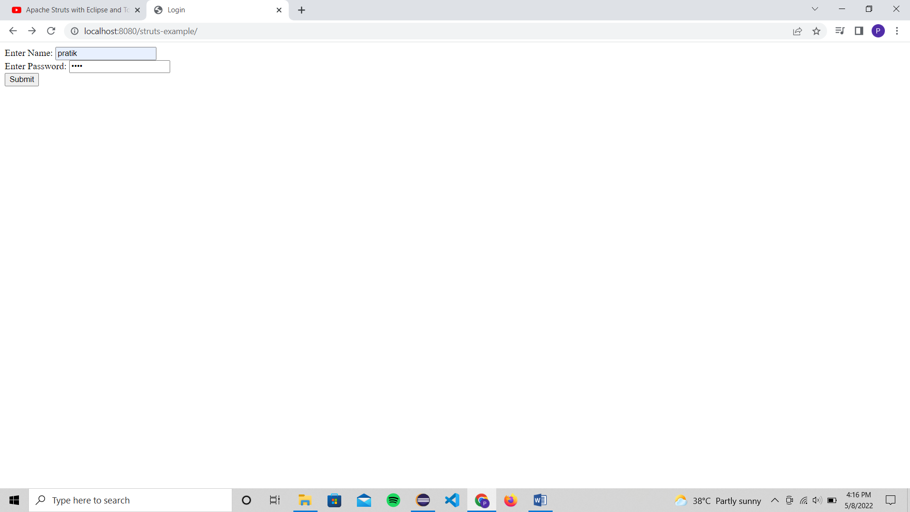
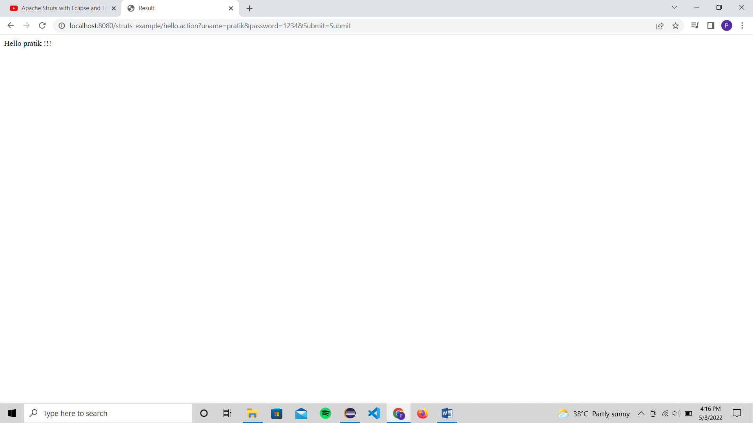
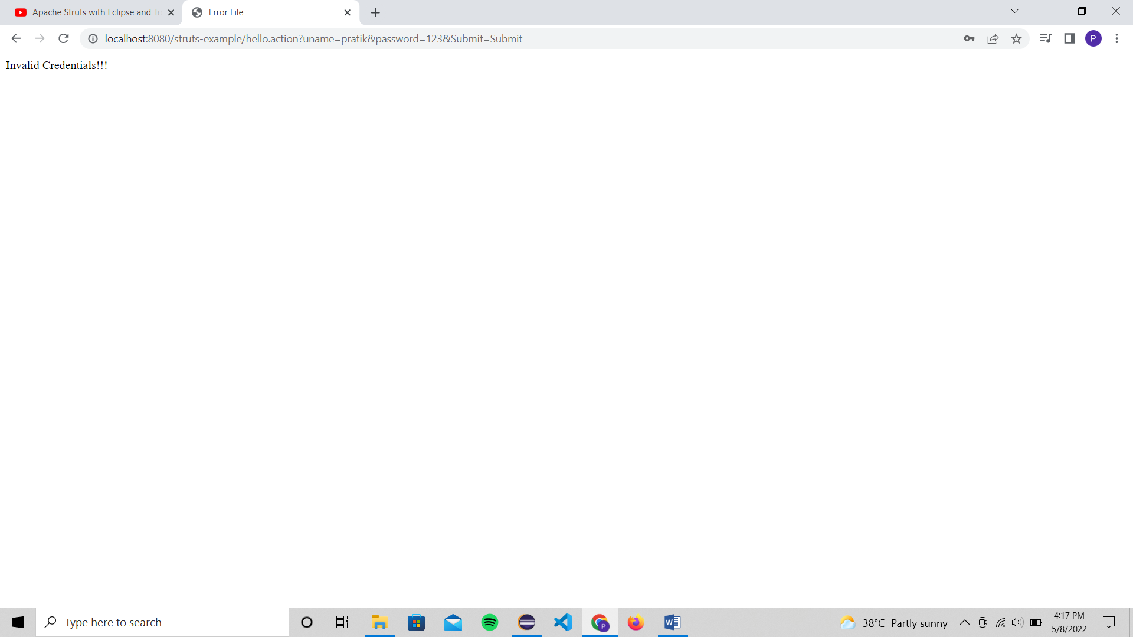
Assignment No. - 09
TITLE
Design and implement login and registration form using AngularJS.
OBJECTIVES
- Understand the working of Struts.
- Perform validations using Struts2.

PROBLEM STATEMENTS
Design and build login and registration form using AngularJS.
OUTCOMES
Students will be able to,
- Develop a dynamic webpage using Angular framework.

- Understand ng-directives.
SOFTWARE NEEDED
- Any Operating System
- JDK 7or later
- Editors; Netbeans/Eclipse
- Web browser
- Tomcat 7 or later

THEORY – CONCEPT
AngularJS- AngularJS is a JavaScript framework written in JavaScript. AngularJS is distributed as a JavaScript file, and can be added to a web page with a script tag.
AngularJS extends HTML with ng-directives.
- The ng-app directive defines an AngularJS application.
- The ng-model directive binds the value of HTML controls (input, select, textarea) to application data.
- The ng-bind directive binds application data to the HTML view.
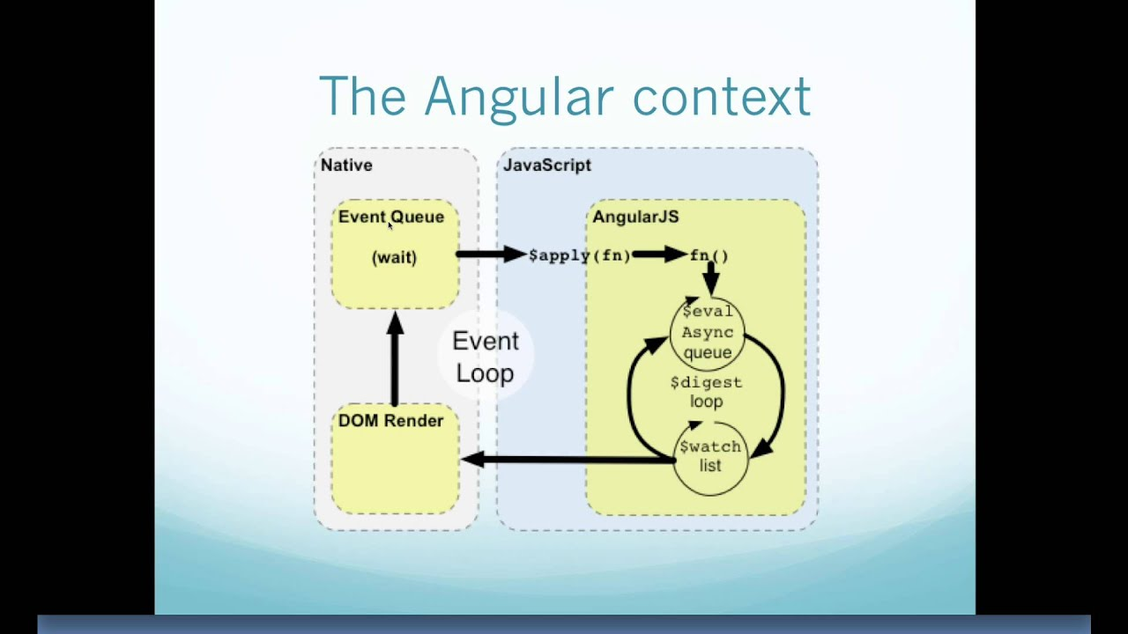
Code
1. register-user.component.html
<div class="login-page">
<mat-card class="mat-elevation-z12">
<mat-card-title style="text-align:center;">SignIn/SignUp</mat-card-title>
<mat-tab-group mat-stretch-tabs class="example-stretched-tabs">
<mat-tab label="Sign In">
<mat-card-content>
<form action="">
<mat-form-field>
<input
matInput
placeholder="Email"
required
name="email"
ngModel
#email="ngModel">
<mat-error *ngIf="email.invalid">Email is required</mat-error>
<mat-icon matSuffix>email</mat-icon>
</mat-form-field>
<mat-form-field>
<input
matInput
placeholder="Password"
type="password"
required
minlength="6"
name="password"
ngModel
#password="ngModel">
<mat-error
*ngIf="password.errors">
Password is required
</mat-error>
<mat-error
*ngIf="password.errors">
Password must be of length 6
</mat-error>
<mat-icon matSuffix>lock</mat-icon>
</mat-form-field>
<mat-checkbox>Remember Me!</mat-checkbox>
<button
mat-raised-button
color="primary"
class="login-button">
Sign In
</button>

<button
mat-raised-button
class="login-button">
Login with Google
</button>
</form>
</mat-card-content>
</mat-tab>
<mat-tab label="Sign Up">
<mat-card-content>
<form action="">
<mat-form-field>
<input
matInput
placeholder="User Name"
required
name="username"
ngModel
#username="ngModel">
<mat-icon matSuffix>perm_identity</mat-icon>
<mat-error
*ngIf="username.invalid">
Username is required
</mat-error>

</mat-form-field>
<mat-form-field>
<input
matInput
placeholder="Email"
required
name="email"
ngModel
#email="ngModel">
<mat-error *ngIf="email.invalid">Email is required</mat-error>
<mat-icon matSuffix>email</mat-icon>
</mat-form-field>
<mat-form-field>
<input
matInput
placeholder="Password"
type="password"
required
minlength="6"
name="password"
ngModel
#password="ngModel">
<mat-error
*ngIf="password.errors">
Password is required
</mat-error>
<mat-error
*ngIf="password.errors">
Password must be of length 6
</mat-error>
<mat-icon matSuffix>lock</mat-icon>

</mat-form-field>
<mat-form-field>
<input
matInput
placeholder="Password"
type="password"
required
minlength="6"
name="repassword"
ngModel
#repassword="ngModel">
<mat-error
*ngIf="repassword.errors">
Re-Enter Password is required
</mat-error>
<mat-icon matSuffix>lock</mat-icon>
</mat-form-field>
<button
mat-raised-button
color="primary"
class="login-button">
Sign Up
</button>
</form>
</mat-card-content>
</mat-tab>
</mat-tab-group>
</mat-card>
</div>

2. register-user.component.css
.login-page {
top: 0;
margin: 0;
padding: 0;
width: 100%;
height: 100%;
display: block;
background-color: #303F9F;
background-position: center;
background-repeat: no-repeat;
background-size: cover;
overflow: hidden;
}

mat-card {
width: 30%;
margin: 10% auto;
border-radius: 8px;
}
mat-form-field, mat-checkbox {
width: 80%;
display: block;
margin: auto;
}
mat-card-content {
margin-top: 20px;
}

.login-button {
margin-top: 20px;
display: block;
width: 80%;
margin: 20px auto;
}

3. app.module.ts
import { BrowserModule } from '@angular/platform-browser';
import { NgModule } from '@angular/core';

import { FormsModule } from '@angular/forms';
import {MatButtonModule} from '@angular/material/button';
import {MatFormFieldModule} from '@angular/material/form-field';
import {MatCardModule} from '@angular/material/card';
import {MatTabsModule} from '@angular/material/tabs';
import {MatInputModule} from '@angular/material/input';
import {MatCheckboxModule} from '@angular/material/checkbox';
import {MatIconModule} from '@angular/material/icon';
import { AppComponent } from './app.component';
import { BrowserAnimationsModule } from '@angular/platform-browser/animations';
import { RegisterUserComponent } from './register-user/register-user.component';
import { ɵAnimationGroupPlayer } from '@angular/animations';
@NgModule({
declarations: [
AppComponent,
RegisterUserComponent
],
imports: [
BrowserModule,
BrowserAnimationsModule,
FormsModule,
MatInputModule,
MatCardModule,
MatTabsModule,
MatFormFieldModule,
MatButtonModule,
MatCheckboxModule,
MatIconModule
],
providers: [],
bootstrap: [AppComponent]
})
export class AppModule { }

4. app.component.spec.ts
import { TestBed } from '@angular/core/testing';
import { RouterTestingModule } from '@angular/router/testing';
import { AppComponent } from './app.component';

describe('AppComponent', () => {
beforeEach(async () => {
await TestBed.configureTestingModule({
imports: [
RouterTestingModule
],
declarations: [
AppComponent
],
}).compileComponents();
});

it('should create the app', () => {
const fixture = TestBed.createComponent(AppComponent);
const app = fixture.componentInstance;
expect(app).toBeTruthy();
});

it(`should have as title 'angular-login'`, () => {
const fixture = TestBed.createComponent(AppComponent);
const app = fixture.componentInstance;
expect(app.title).toEqual('angular-login');
});

it('should render title', () => {
const fixture = TestBed.createComponent(AppComponent);
fixture.detectChanges();
const compiled = fixture.nativeElement as HTMLElement;
expect(compiled.querySelector('.content span')?.textContent).toContain('angular-login app is running!');
});
});

Output
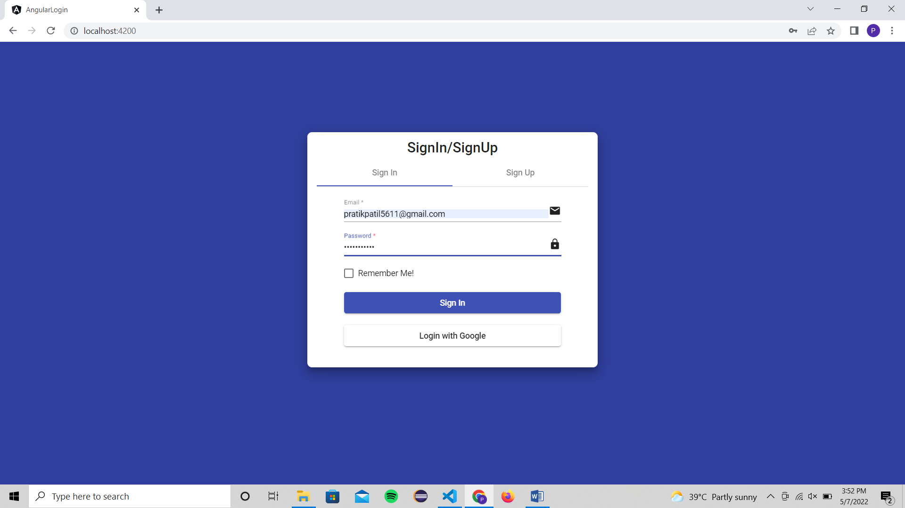
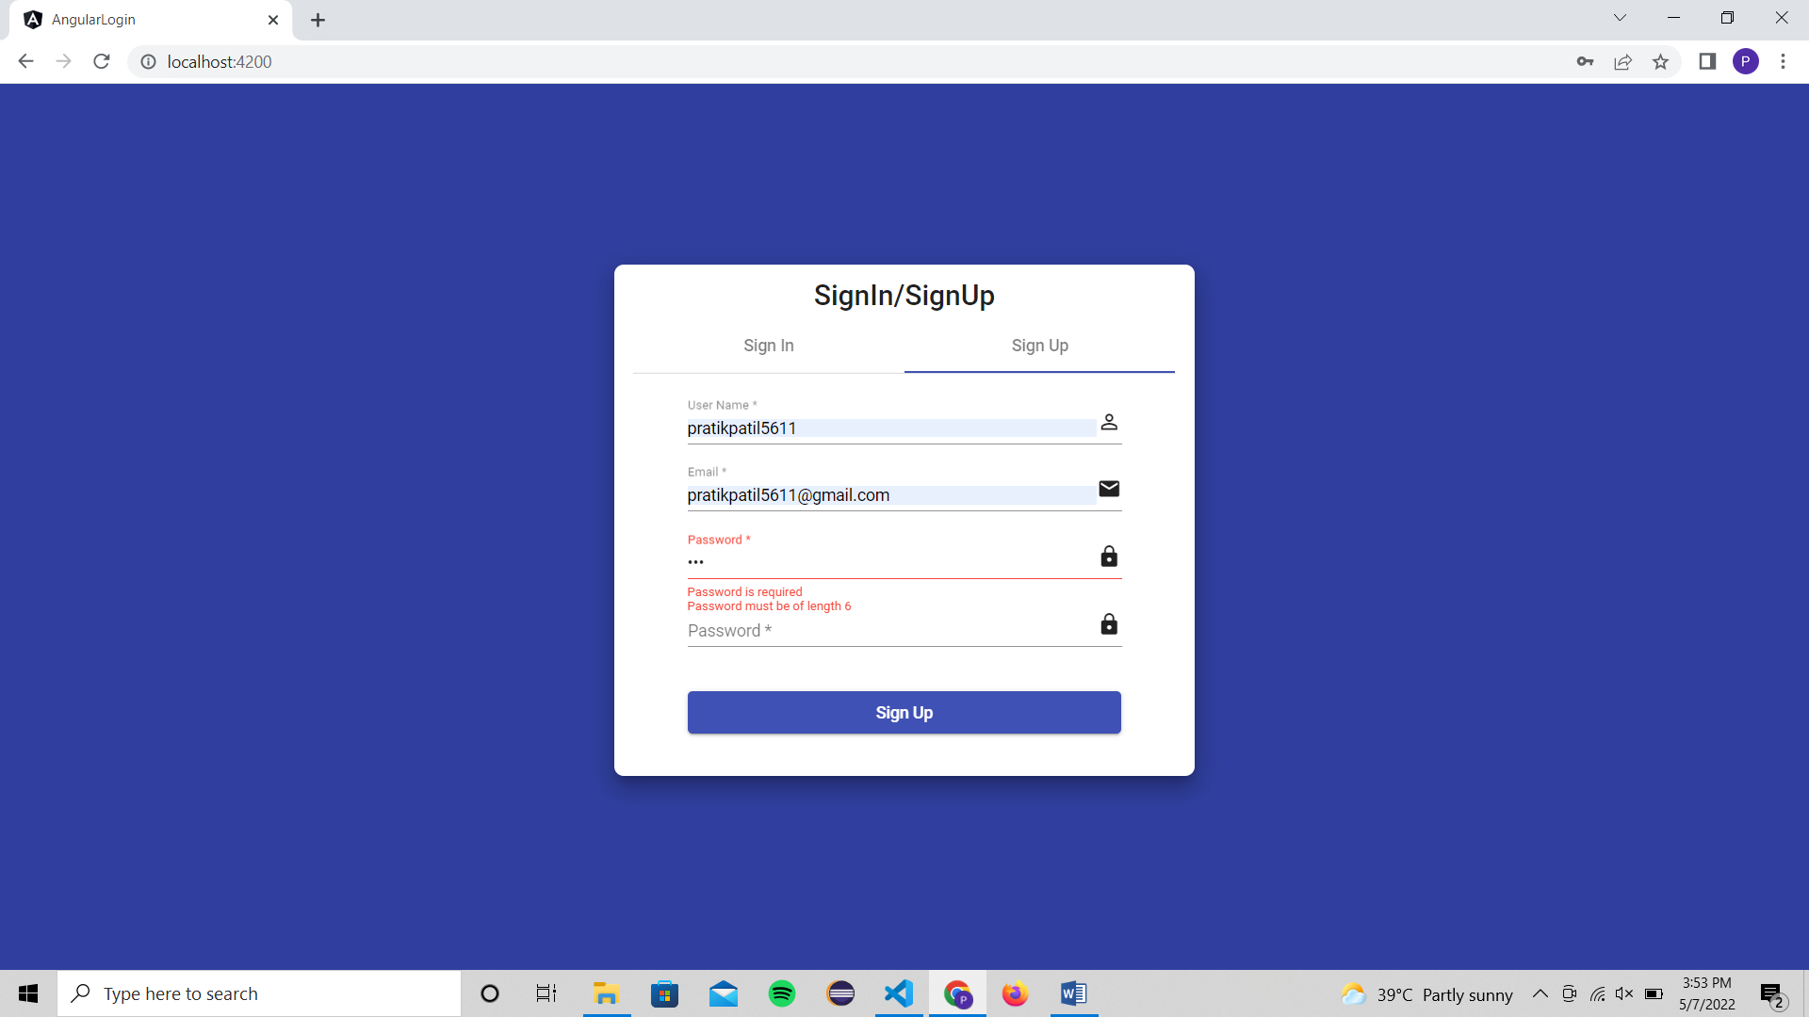

Assignment No. - 10
TITLE
Design and implement banking application using EJB.
OBJECTIVES
- Understand the working of EJB.
- Perform operations using EJB.

PROBLEM STATEMENTS
Design and build basic banking application using EJB.
OUTCOMES
Students will be able to,
- Develop a dynamic webpage using EJB.

- Understand use of EJB server in application.
SOFTWARE NEEDED
- Any Operating System
- JDK 7or later
- Editors; Netbeans/Eclipse
- Web browser
- Tomcat 7 or later

THEORY – CONCEPT
EJB is a server-side software element that summarizes business logic of an application. Enterprise Java Beans web repository yields a runtime domain for web related software elements including computer reliability, Java Servlet Lifecycle (JSL) management, transaction procedure and other web services.
Types of Enterprise Java Beans
There are three types of EJB:
1. Session Bean: Session bean contains business logic that can be invoked by local, remote or webservice client.
- Stateful Session bean
- Stateless Session bean
2. Message Driven Bean: Like Session Bean, it contains the business logic but it is invoked by passing message.
3. Entity Bean: It summarizes the state that can be remained in the database. It is deprecated. Now, it is replaced with JPA (Java Persistent API).
- Bean Managed Persistence
- Container Managed Persistence

Code
1. index.html
<!DOCTYPE html>
<html>
<head>
<title>Implement Bank Application using EJB</title>
<meta charset="UTF-8">
<meta name="viewport" content="width=device-width, initial-scale=1.0">
</head>
<body>

<form method="post" action="transact">
<h1> Bank Application using EJB </h1>
Enter Amount : <input type="text" name="t1" /> <br/> <br/>

<h3>Select options</h3>
<input type="radio" name="transaction" value="withdraw" /> Withdraw <br/>
<input type="radio" name="transaction" value="deposit" /> Deposit <br/>
<input type="submit" value="Submit" />
</form>
</body>
</html>
2. BankTransact.java (EJB)
package bankexamp;
import javax.ejb.Stateful;
@Stateful
public class BankTransact implements BankTransactLocal {
int balance = 10000;
@Override
public int deposit(int amount) {
balance = balance + amount;
return balance;
}
@Override
public int withdraw(int amount) {
balance = balance - amount;
return balance;
}
}
3. BankTransactLocal.java (EJB Local)
package bankexamp;
import javax.ejb.Local;
@Local
public interface BankTransactLocal {
int withdraw(int amount);
int deposit(int amount);
}
4. transact.java
import bankexamp.BankTransactLocal;
import java.io.IOException;
import java.io.PrintWriter;
import java.util.logging.Level;
import java.util.logging.Logger;
import javax.naming.Context;
import javax.naming.InitialContext;
import javax.naming.NamingException;
import javax.servlet.ServletException;
import javax.servlet.http.HttpServlet;
import javax.servlet.http.HttpServletRequest;
import javax.servlet.http.HttpServletResponse;

public class transact extends HttpServlet {
BankTransactLocal bankTransact = lookupBankTransactLocal();
protected void processRequest(HttpServletRequest request, HttpServletResponse response)
throws ServletException, IOException {
response.setContentType("text/html;charset=UTF-8");
try (PrintWriter out = response.getWriter()) {

String selectedType = request.getParameter("transaction");
int amount = Integer.parseInt(request.getParameter("t1"));

if(selectedType.equals("deposit")){
int amt=bankTransact.deposit(amount);
out.println(amount +" successfully deposited.<br/> Your Balance is : Rs."+amt);
}
if(selectedType.equals("withdraw")){
int amt = bankTransact.withdraw(amount);
out.println(amount +" successfully Withdrawn. <br/> Your Balance is : Rs."+amt);
}
}

}
@Override
protected void doGet(HttpServletRequest request, HttpServletResponse response)
throws ServletException, IOException {
processRequest(request, response);
}
@Override
public String getServletInfo() {
return "Short description";
}
private BankTransactLocal lookupBankTransactLocal() {
try {
Context c = new InitialContext();
return (BankTransactLocal) c.lookup("java:global/bank/bank-ejb/BankTransact!bankexamp.BankTransactLocal");
} catch (NamingException ne) {
Logger.getLogger(getClass().getName()).log(Level.SEVERE, "exception caught", ne);
throw new RuntimeException(ne);
}
}
}
Output
